Module 04 Lab 01 Model Development Used Car Pricing Screenshot Evidence and Discussion
Reference label for this notebook: Lab1 (each heading below is numbered Lab1_1, Lab1_2 and so on).
This document collects the screenshots of Module 04 Lab 01, model development on the used car dataset, with a heading for every step of the notebook. The lab builds simple and multiple linear regressions, examines the residuals with regression and residual plots, fits polynomials of increasing order, and wraps the steps in pipelines before scoring the models with R squared and the mean squared error. Every screenshot is captioned with its file name.

Lab1_1. Section 0 Setup and library installation
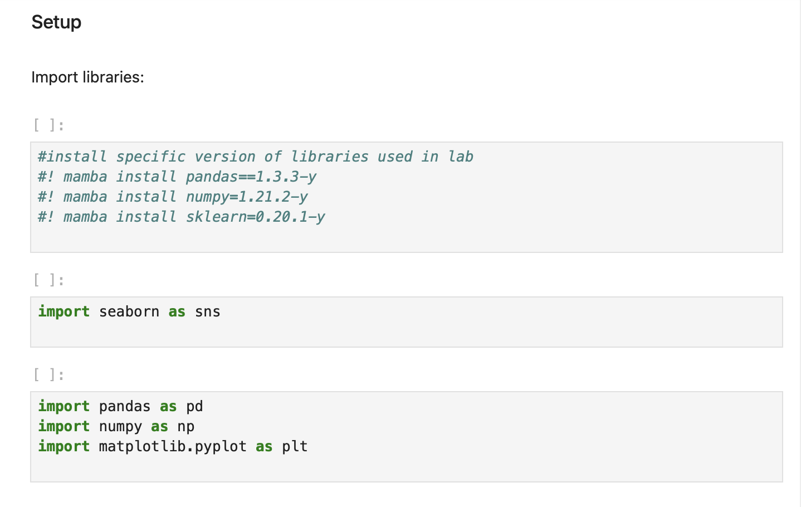
Screenshot file: 1_setup_import_libraries_mamba_install.png
The notebook opens with the commented mamba install line so the environment can be reproduced, followed by the imports used by the modelling cells.

Lab1_2. Section 0 Downloading the prepared dataset
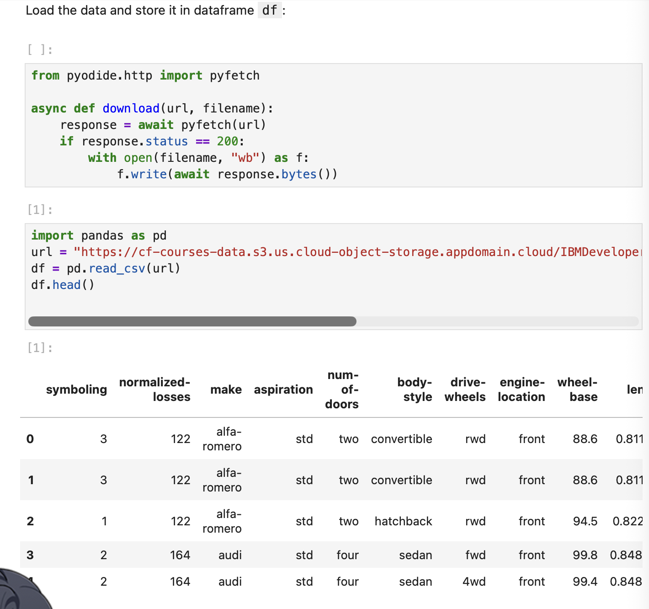
Screenshot file: 2_load_data_to_dataframe_df.png
The download helper fetches the prepared automobile file into the working folder, which is the file the following cell reads.

Lab1_3. Section 0 Reading automobileEDA.csv into the dataframe
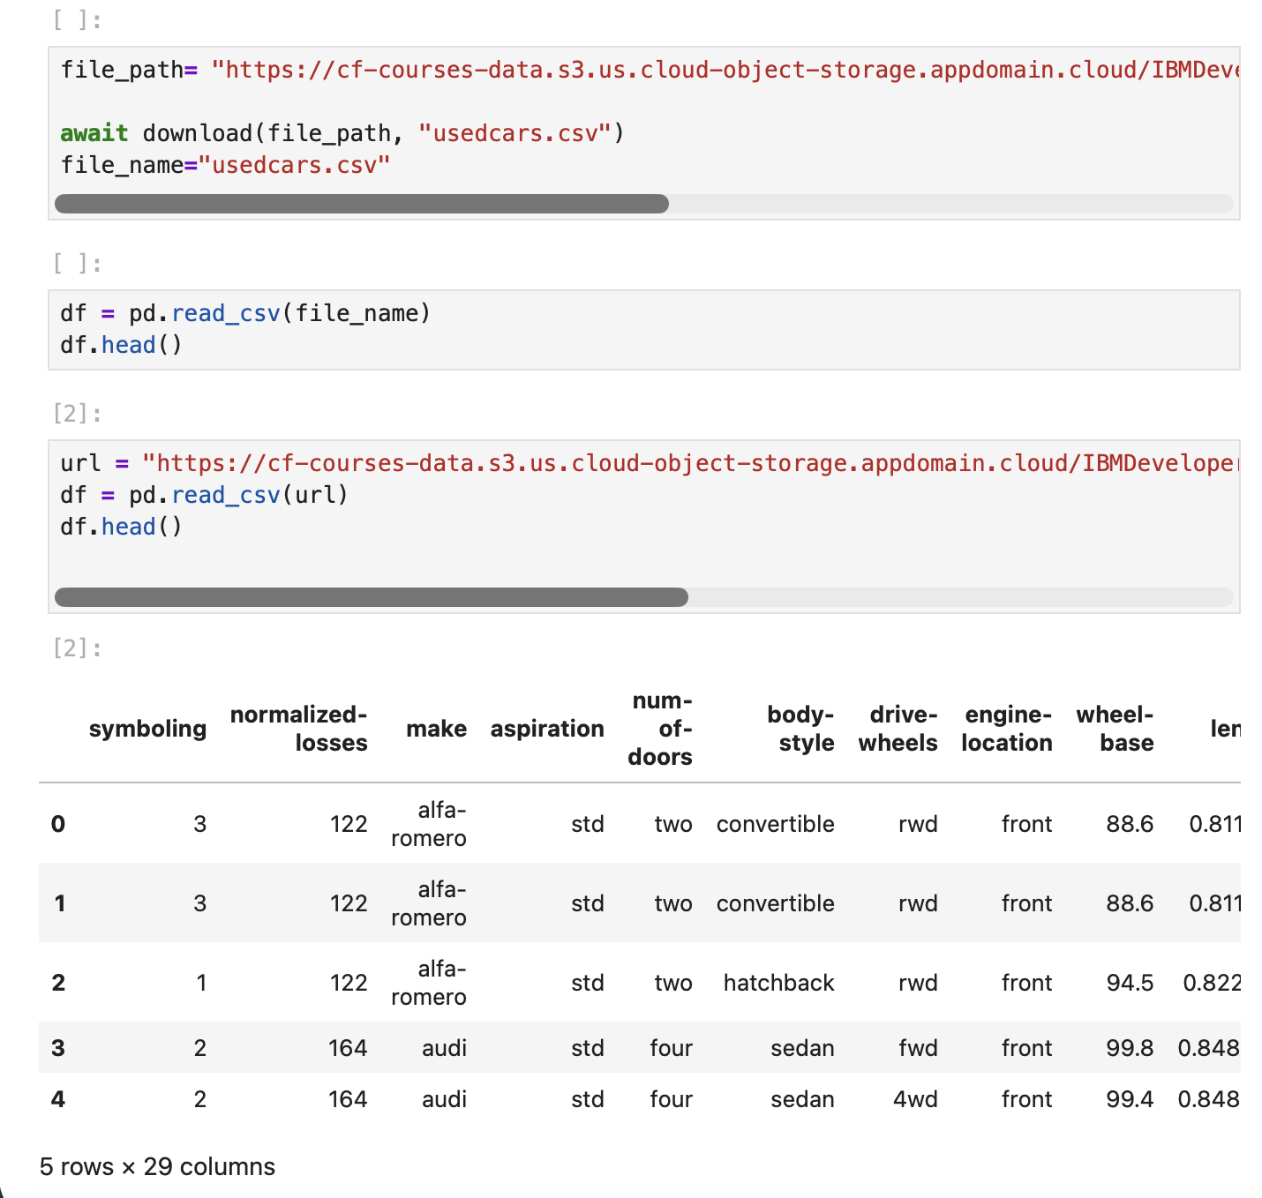
Screenshot file: 3_download_and_read_usedcars_csv.png
The URL of the prepared data is set and pd.read_csv loads it into df; df.head() shows the first rows of the 201 sales used by every model in the lab.

Lab1_4. Section 1 Simple linear regression with horsepower
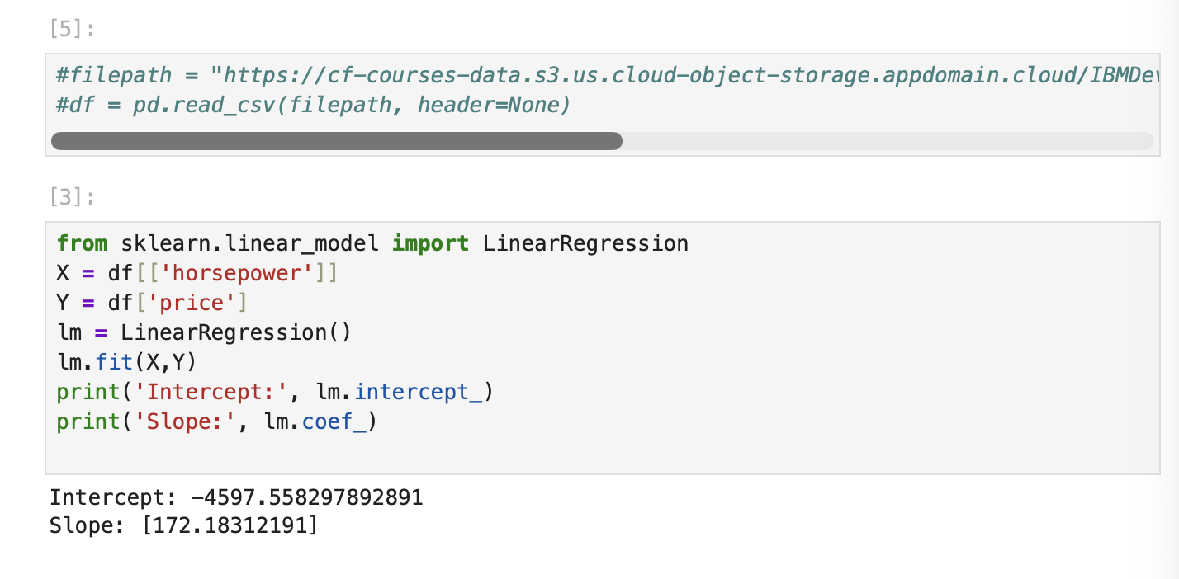
Screenshot file: 4_simple_linear_regression_horsepower_price.png
The first worked example pairs horsepower with price, showing how a single feature enters a simple linear regression.

Lab1_5. Section 1 Importing LinearRegression and creating the model
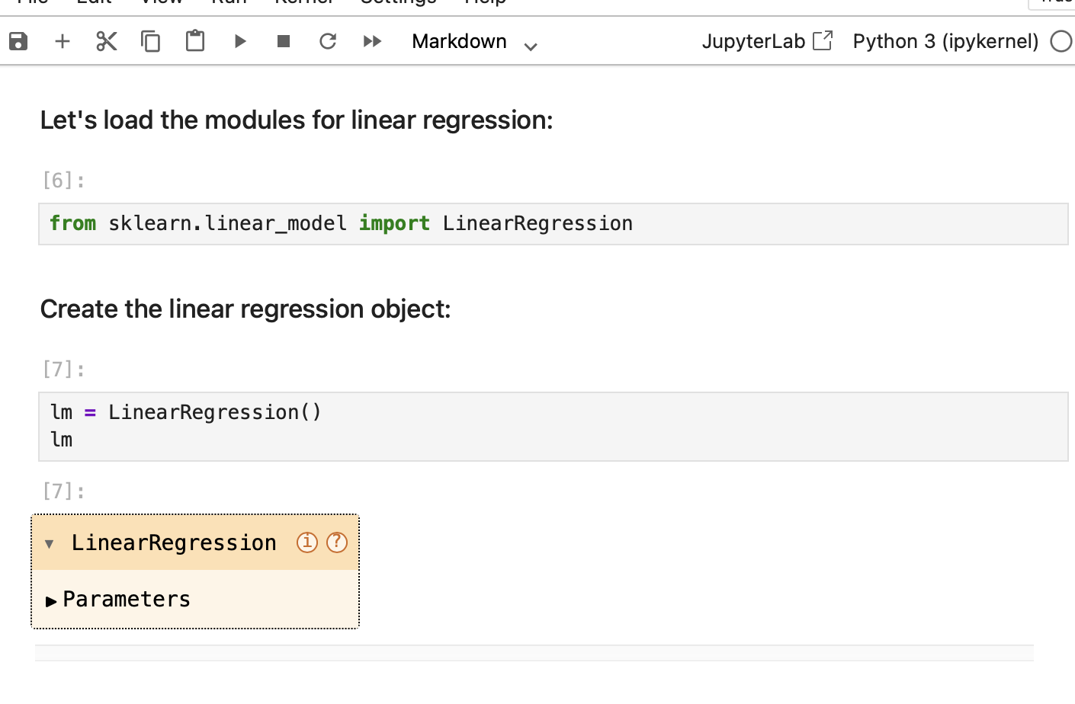
Screenshot file: 5_linear_regression_import_and_object_creation.png
LinearRegression is imported from sklearn.linear_model and the regression object is created, the step that every later model repeats.

Lab1_6. Section 1 Simple linear regression with highway-mpg
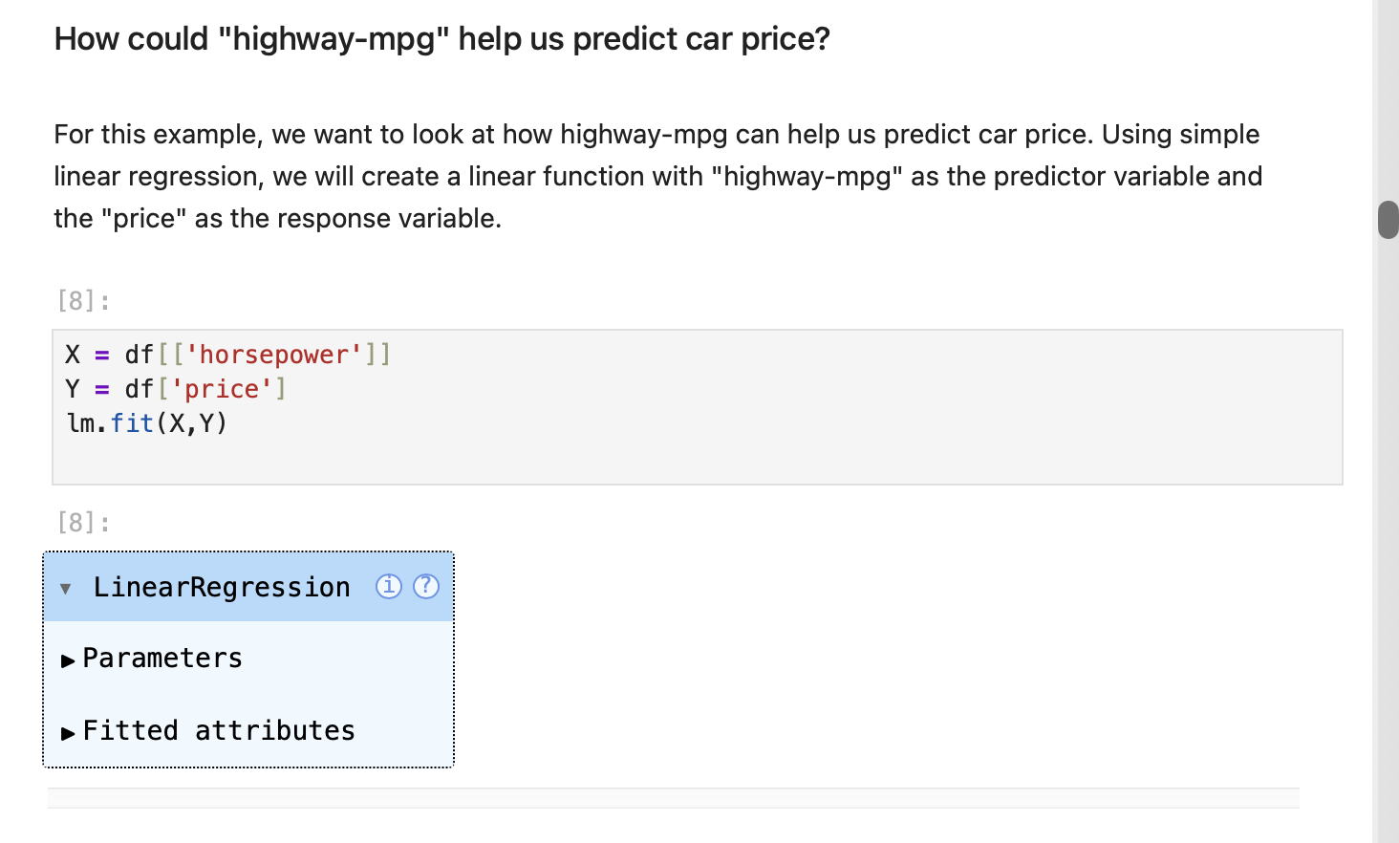
Screenshot file: 6_simple_linear_regression_highway_mpg_price.png
highway-mpg is used as the predictor of price, following the same pattern as the engine-size example in the earlier module.

Lab1_7. Section 1 Fitting the model and producing predictions
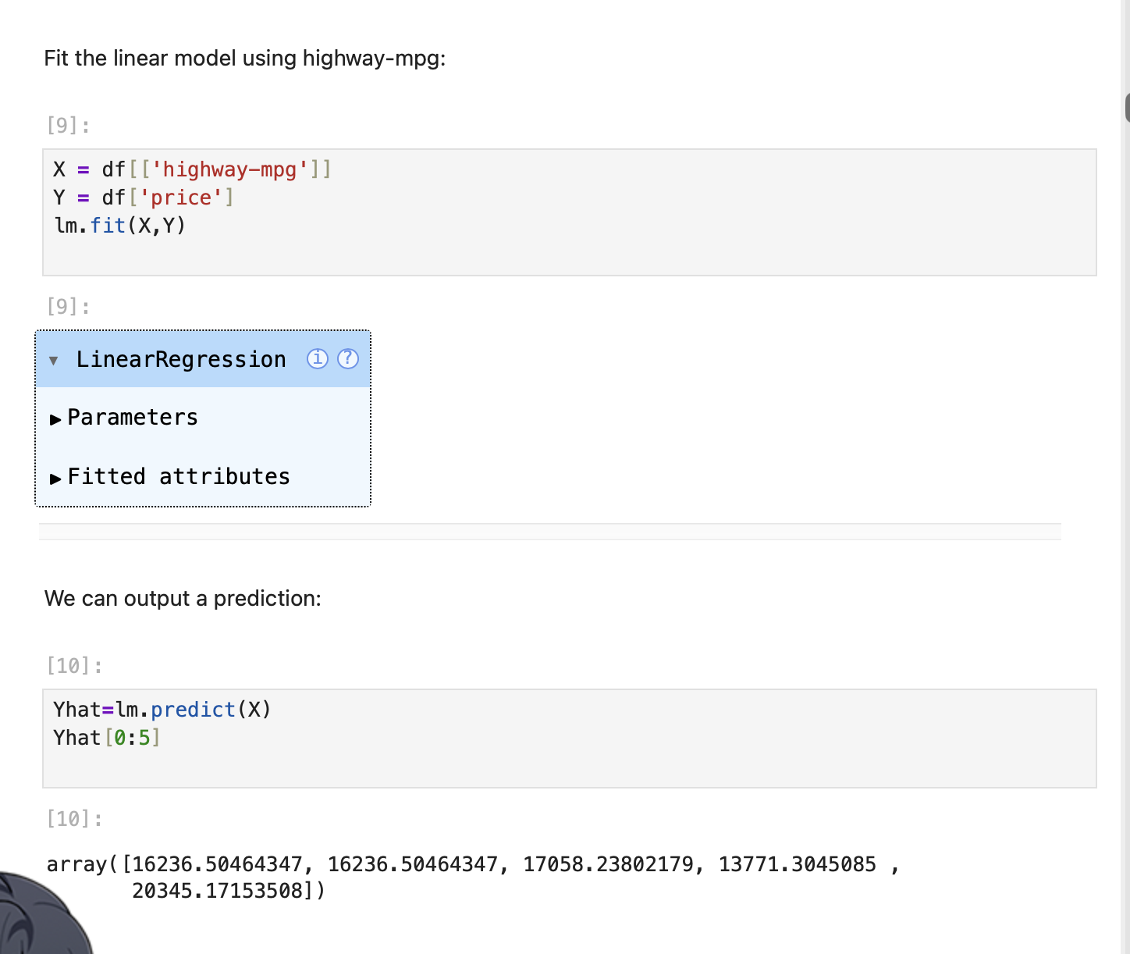
Screenshot file: 7_fit_highway_mpg_model_and_predict.png
lm.fit trains the model on the pair of variables and lm.predict returns the fitted values Yhat.

Lab1_8. Section 1 The predicted values for the first rows
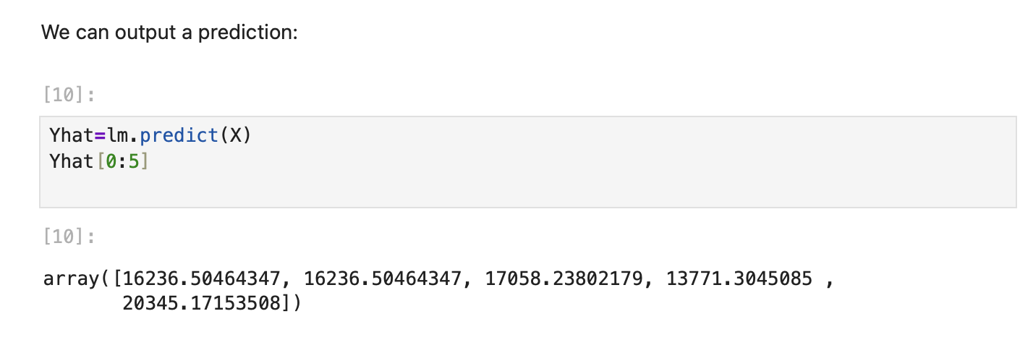
Screenshot file: 8_predict_highway_mpg.png
Yhat[0:5] prints the first five fitted prices so the output of the model can be inspected.

Lab1_9. Section 1 Intercept and slope of the highway-mpg model
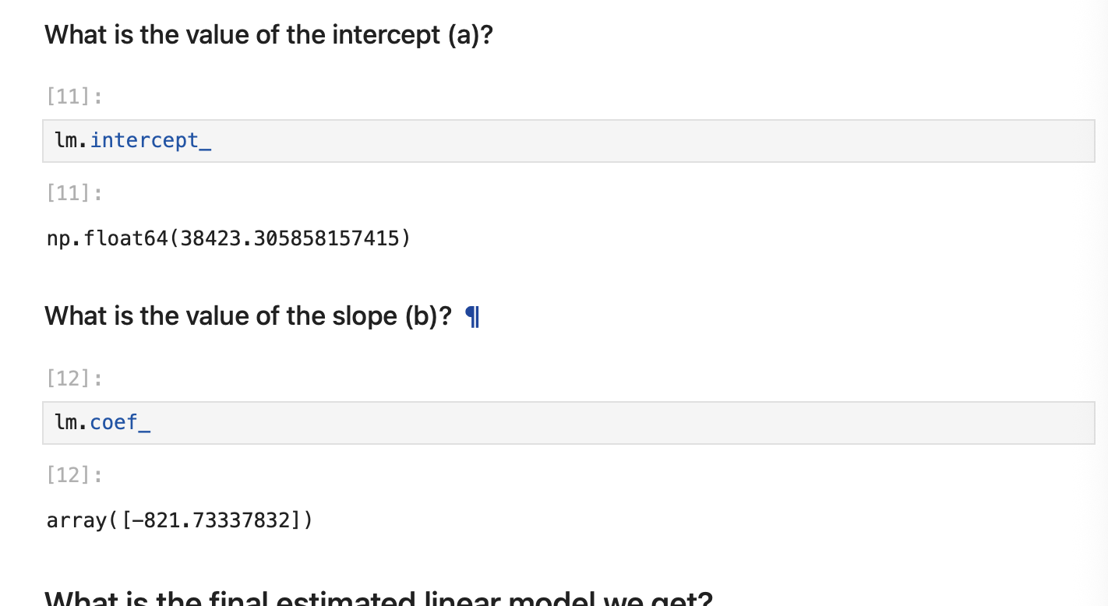
Screenshot file: 9_intercept_slope_highway_mpg.png
lm.intercept_ and lm.coef_ return the two parameters of the fitted line, which together answer the slope question in the text.

Lab1_10. Question 1 a) Creating the linear regression object lm1
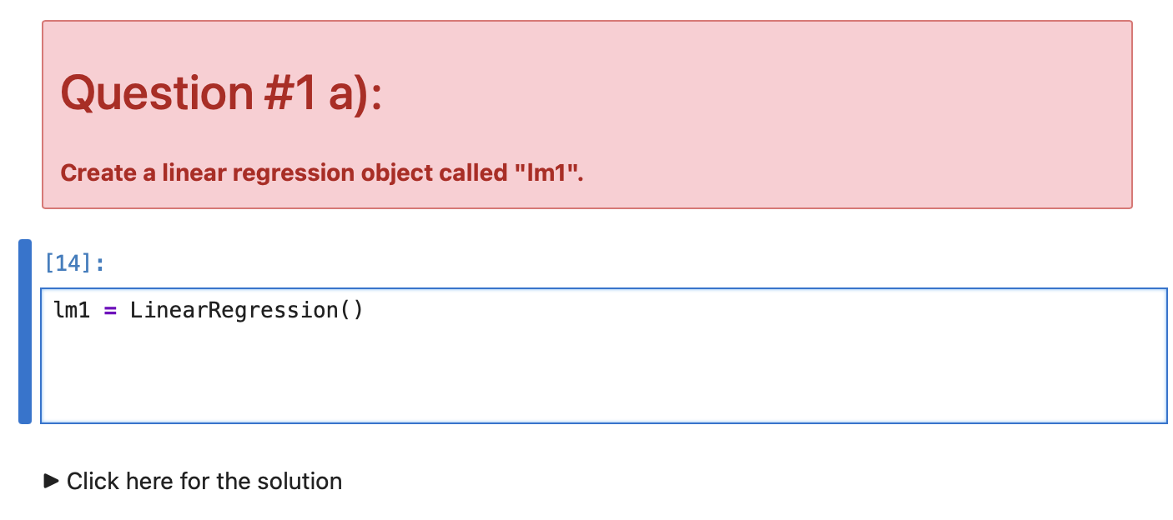
Screenshot file: 10_q1a_create_lm1.png
lm1 = LinearRegression() creates the object the question asks for, ready to be trained on engine-size and price.

Lab1_11. Question 1 b) Training lm1 on engine-size and price
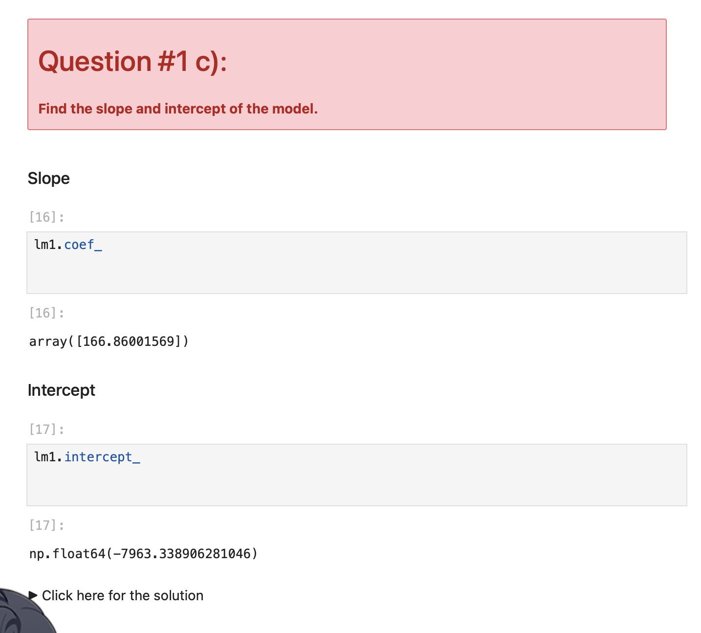
Screenshot file: 10_q1b_create_lm1.png
lm1.fit is called with engine-size as the independent variable and price as the dependent variable.

Lab1_12. Question 1 c) Slope and intercept of lm1
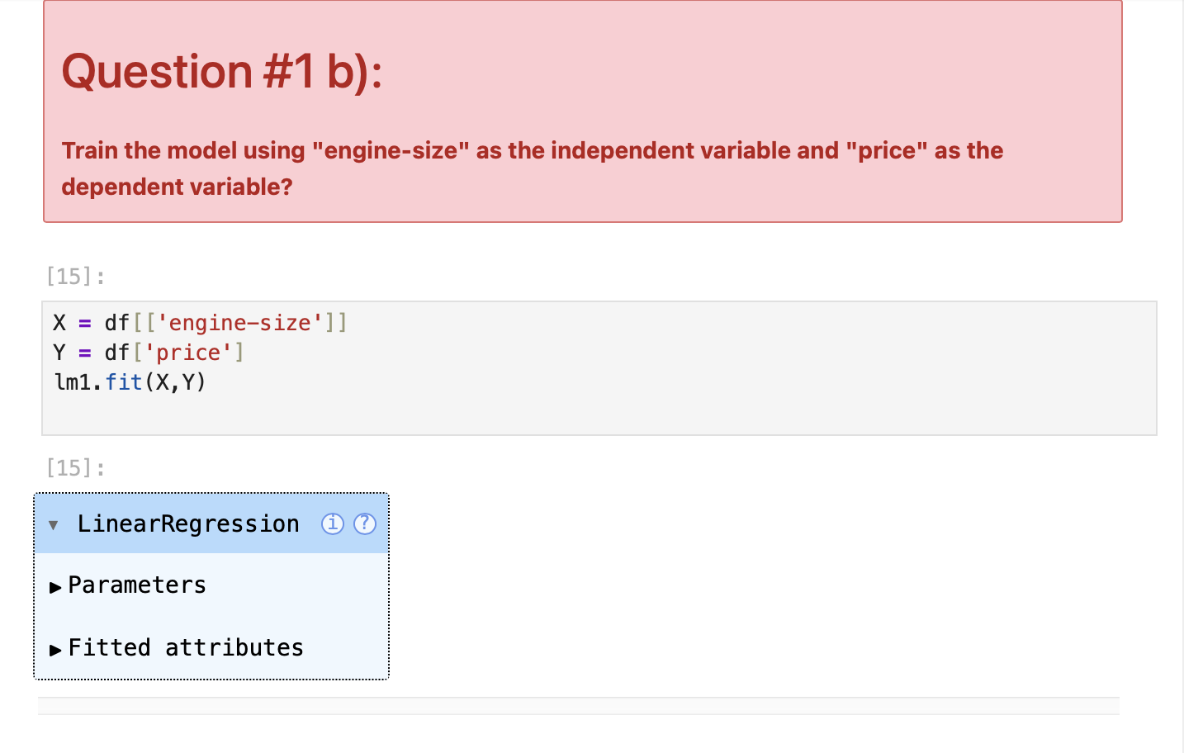
Screenshot file: 10_q1c_create_lm1.png
lm1.intercept_ and lm1.coef_ return about -7963.34 and 166.86, the two numbers that describe the fitted line.

Lab1_13. Question 1 d) The equation of the fitted line
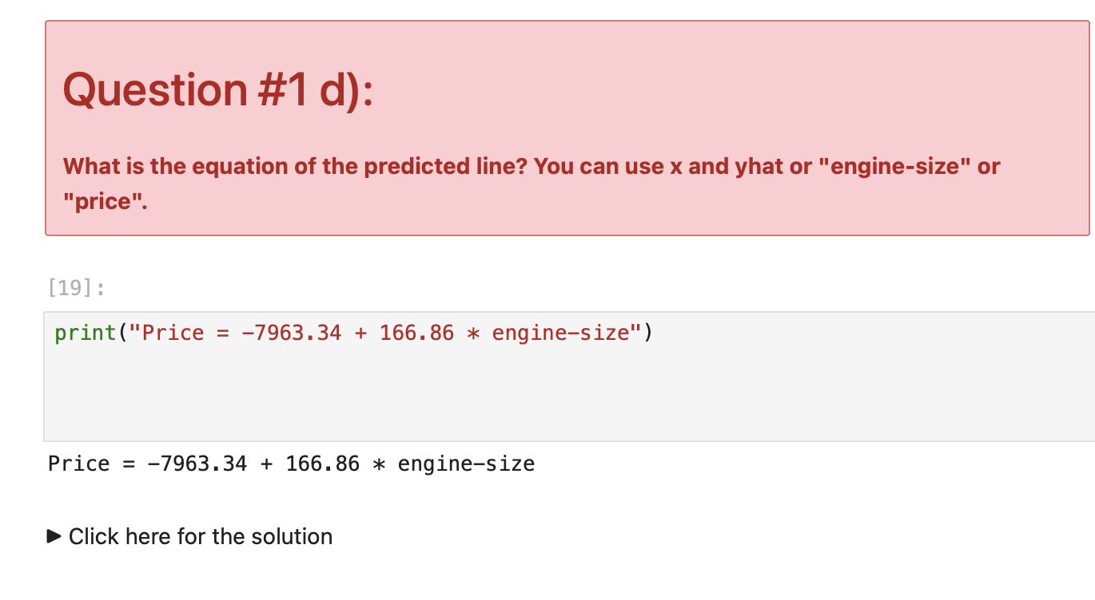
Screenshot file: 10_q1d_create_lm1.png
The answers combine into Price = -7963.34 + 166.86 x engine-size, which is the equation the question asks for.

Lab1_14. Section 2 Multiple linear regression with four features
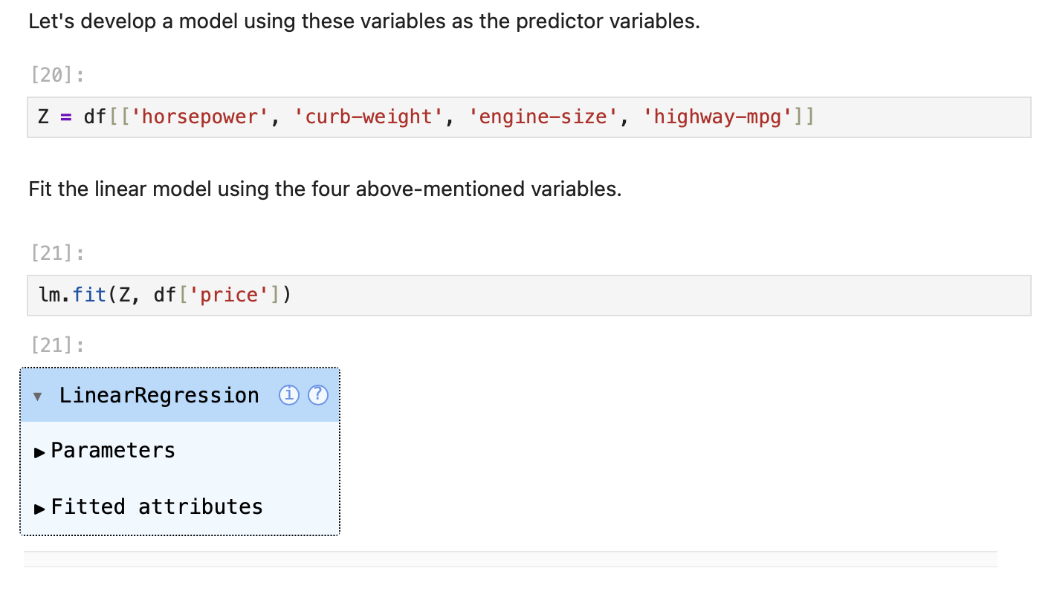
Screenshot file: 11_mlr_fit_four_features.png
The second model is trained on horsepower, curb-weight, engine-size and highway-mpg together, following the multiple regression example.

Lab1_15. Section 2 Coefficients of the multiple regression
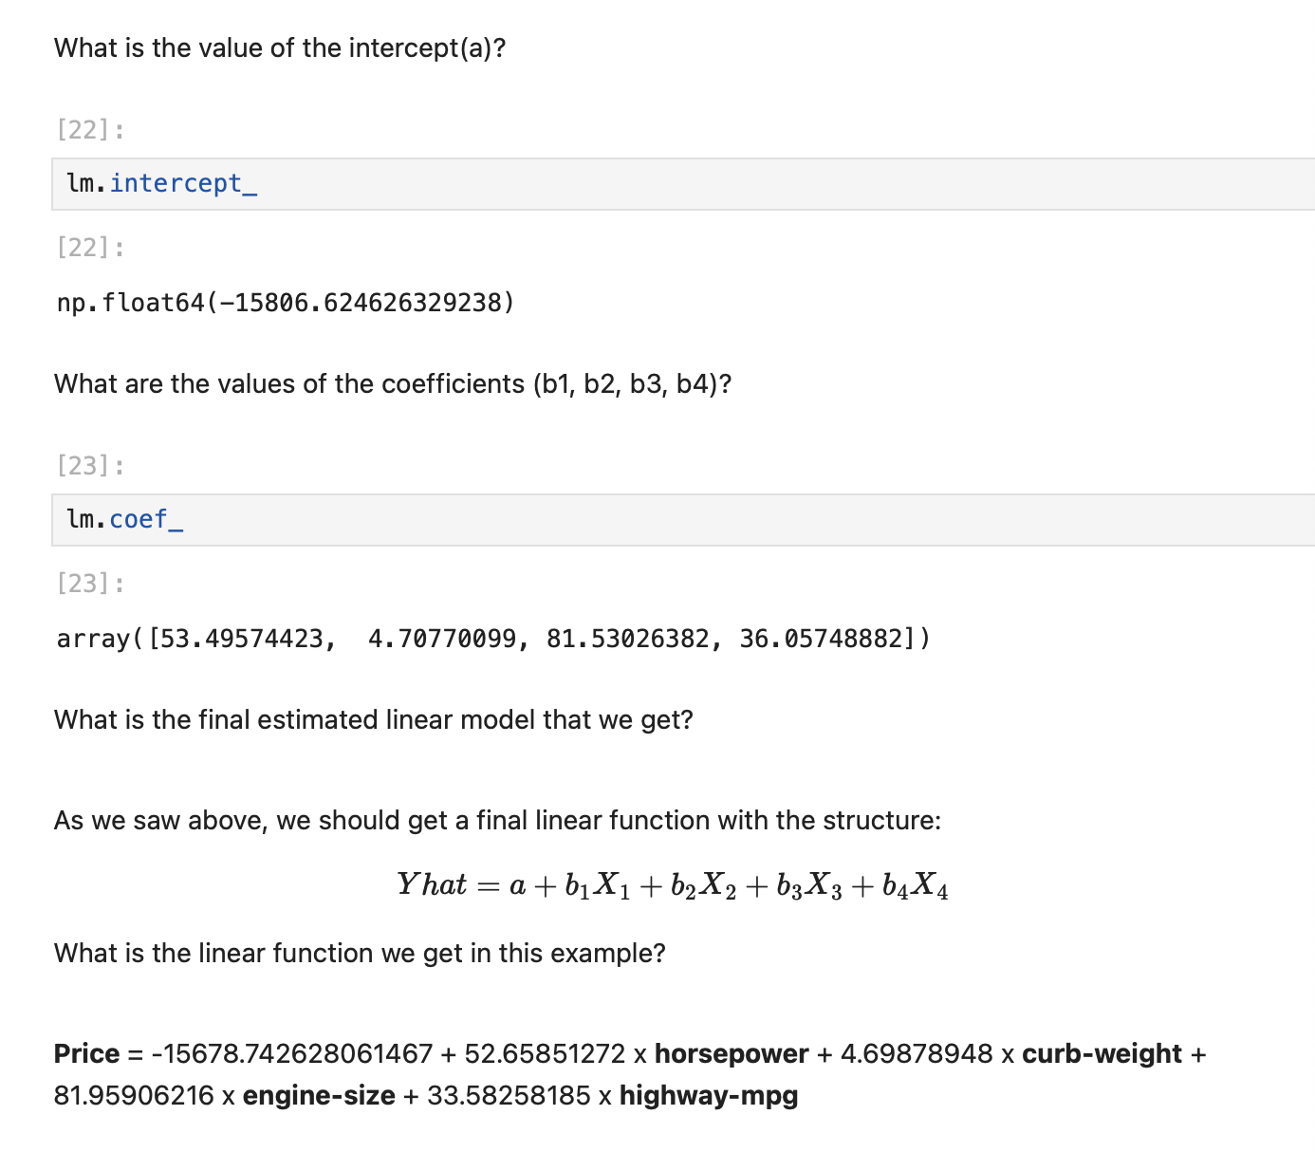
Screenshot file: 12_mlr_intercept_coef.png
The printed equation lists one coefficient per feature, which shows how much each attribute contributes to the predicted price.

Lab1_16. Question 2 a) Creating and training the model lm2
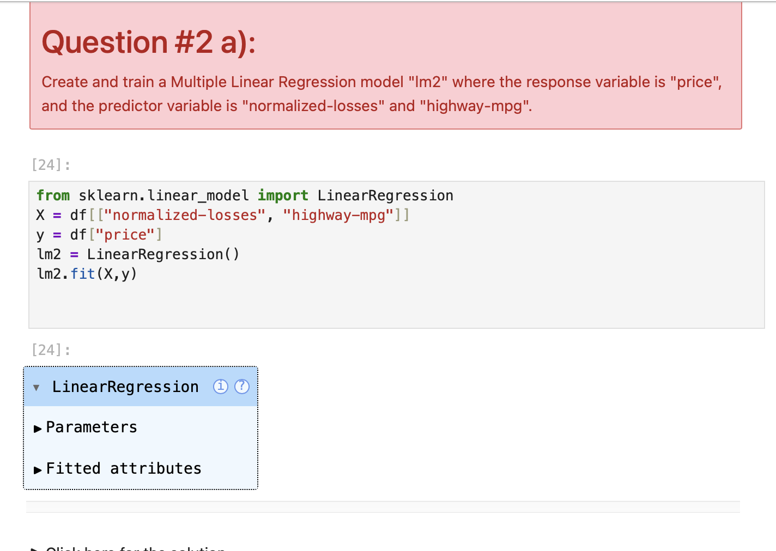
Screenshot file: 13_q2a_mlr_lm2.png
lm2 is created and fitted with normalized-losses and highway-mpg as the predictors of price, exactly as the question specifies.

Lab1_17. Section 3 Evaluating the models with regression plots
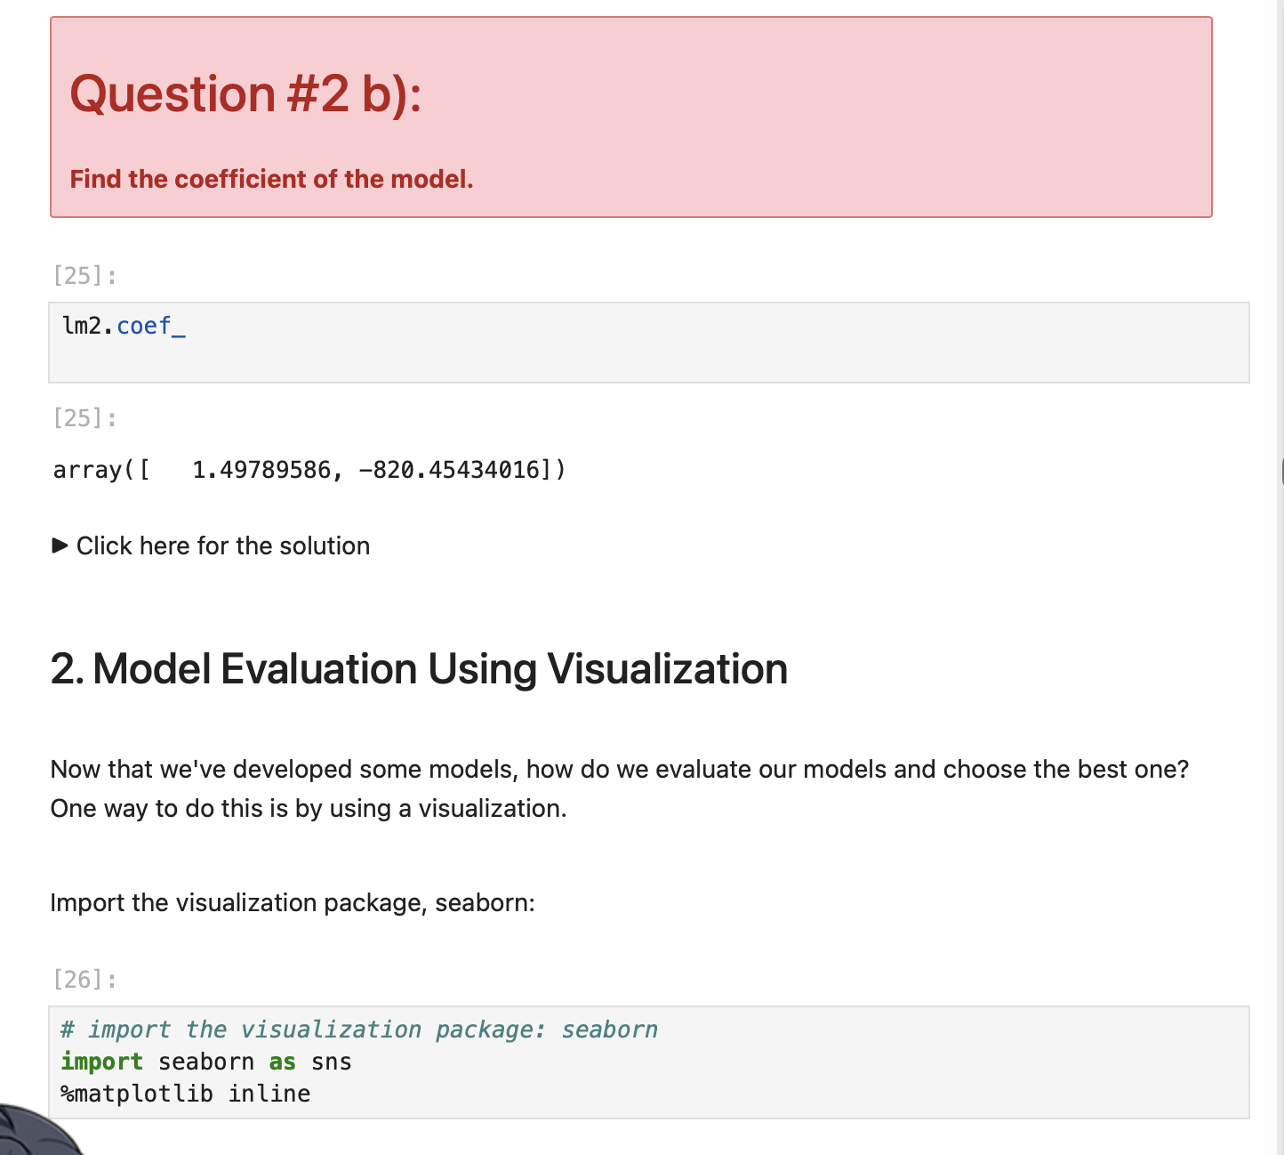
Screenshot file: 13_q2a_1mlr_lm2.png
The regression plot of highway-mpg against price shows the negative slope that the notebook comments on.

Lab1_18. Section 3 Residual plot for highway-mpg
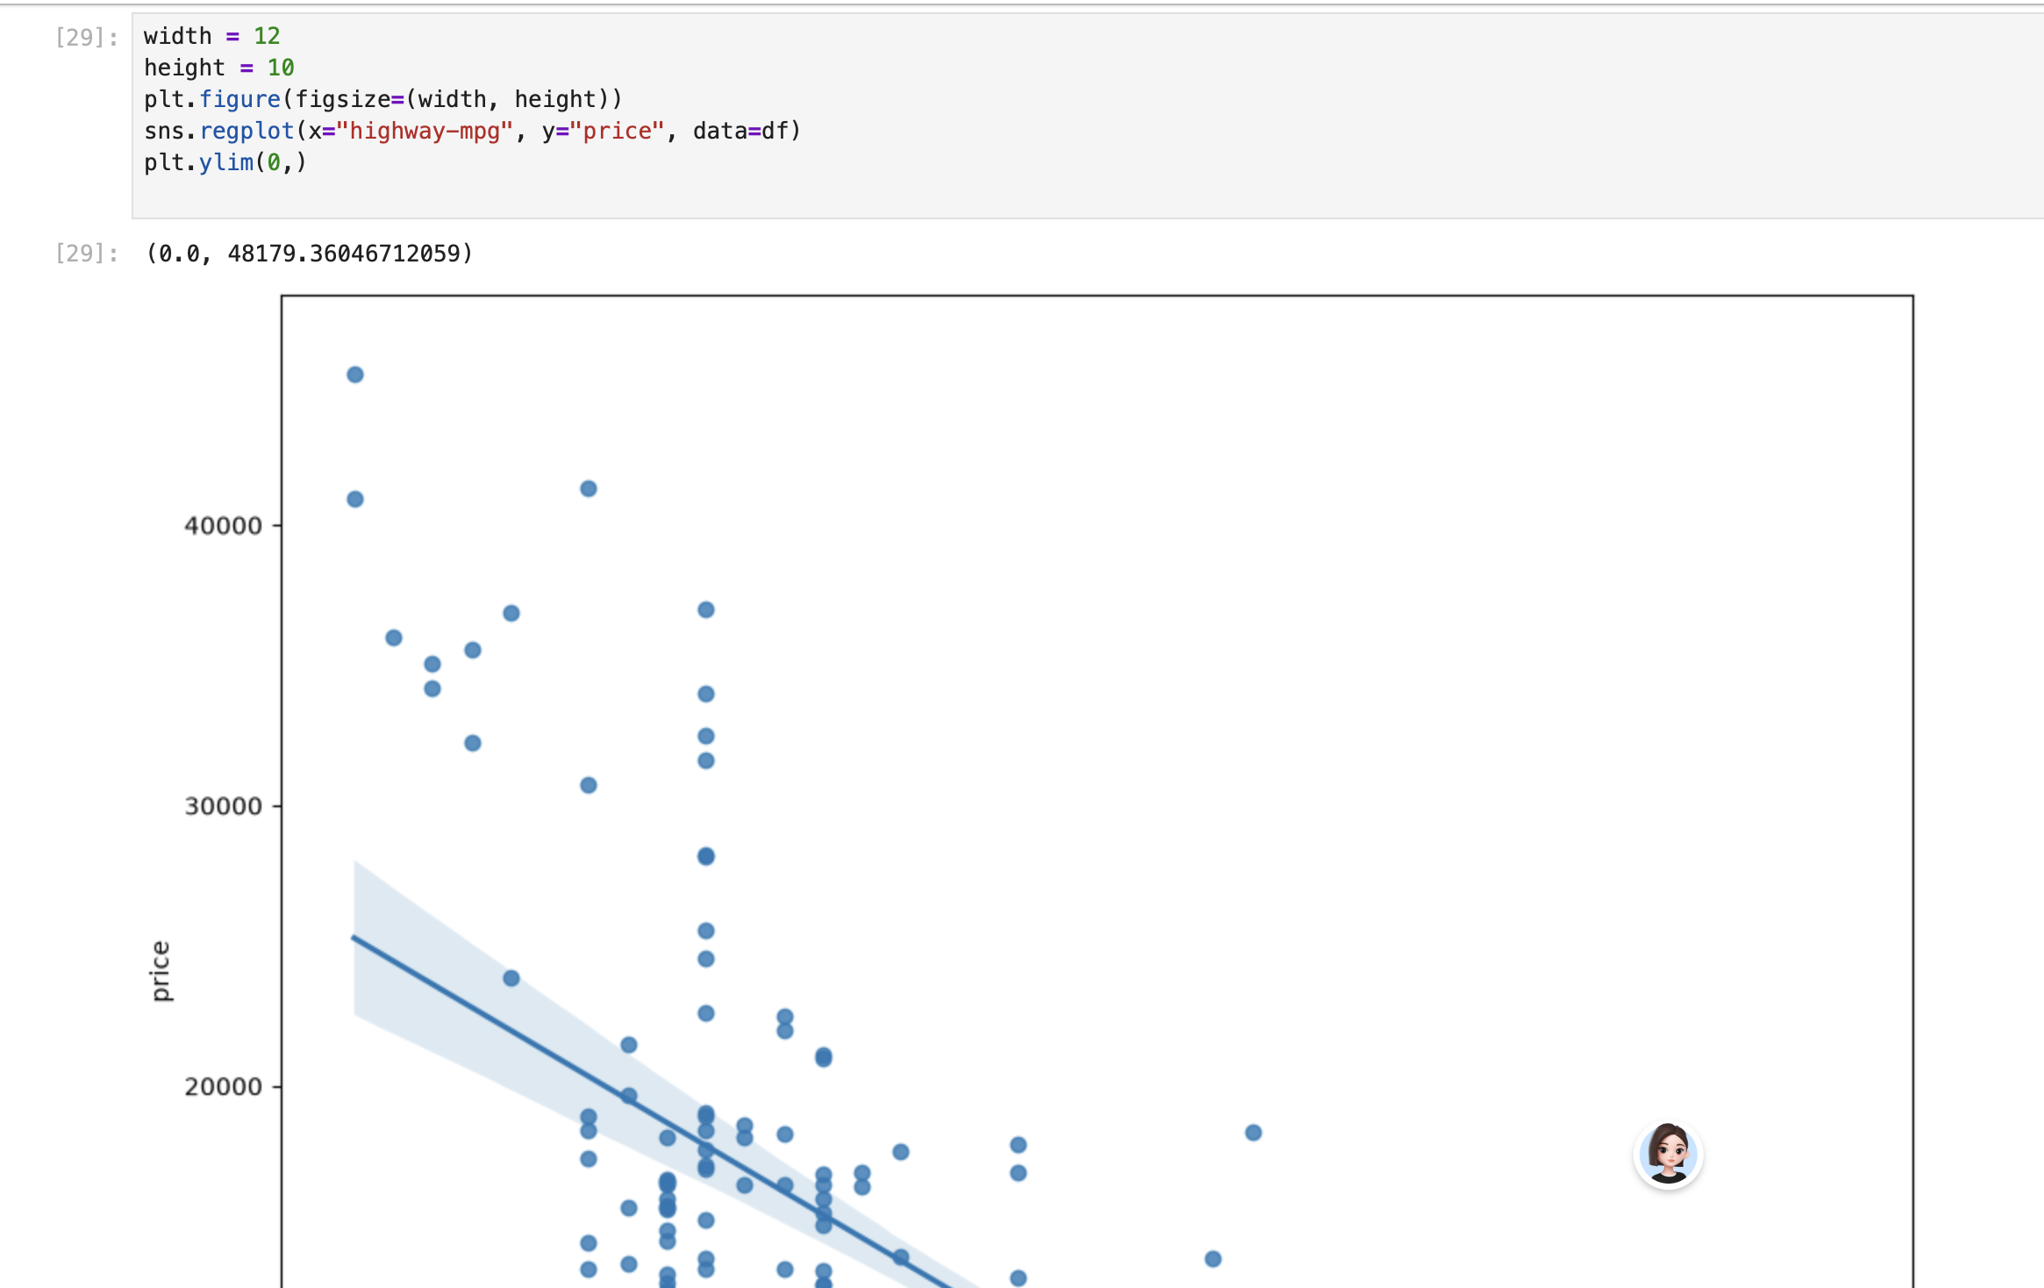
Screenshot file: 13_q2a_2mlr_lm2.png
The residual plot is used to judge whether a straight line is an appropriate description of the relationship.

Lab1_19. Section 3 Reading the residual plot
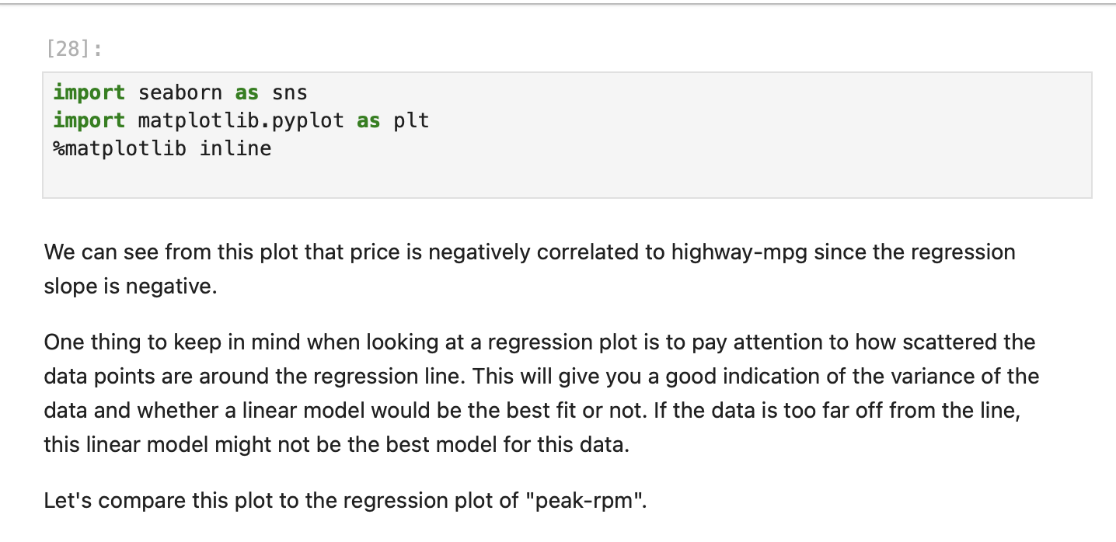
Screenshot file: 13_q2a_3mlr_lm2.png
The comment under the plot explains that the curvature in the residuals indicates that the linear fit is not ideal for highway-mpg.

Lab1_20. Section 3 Second regression plot with a larger figure
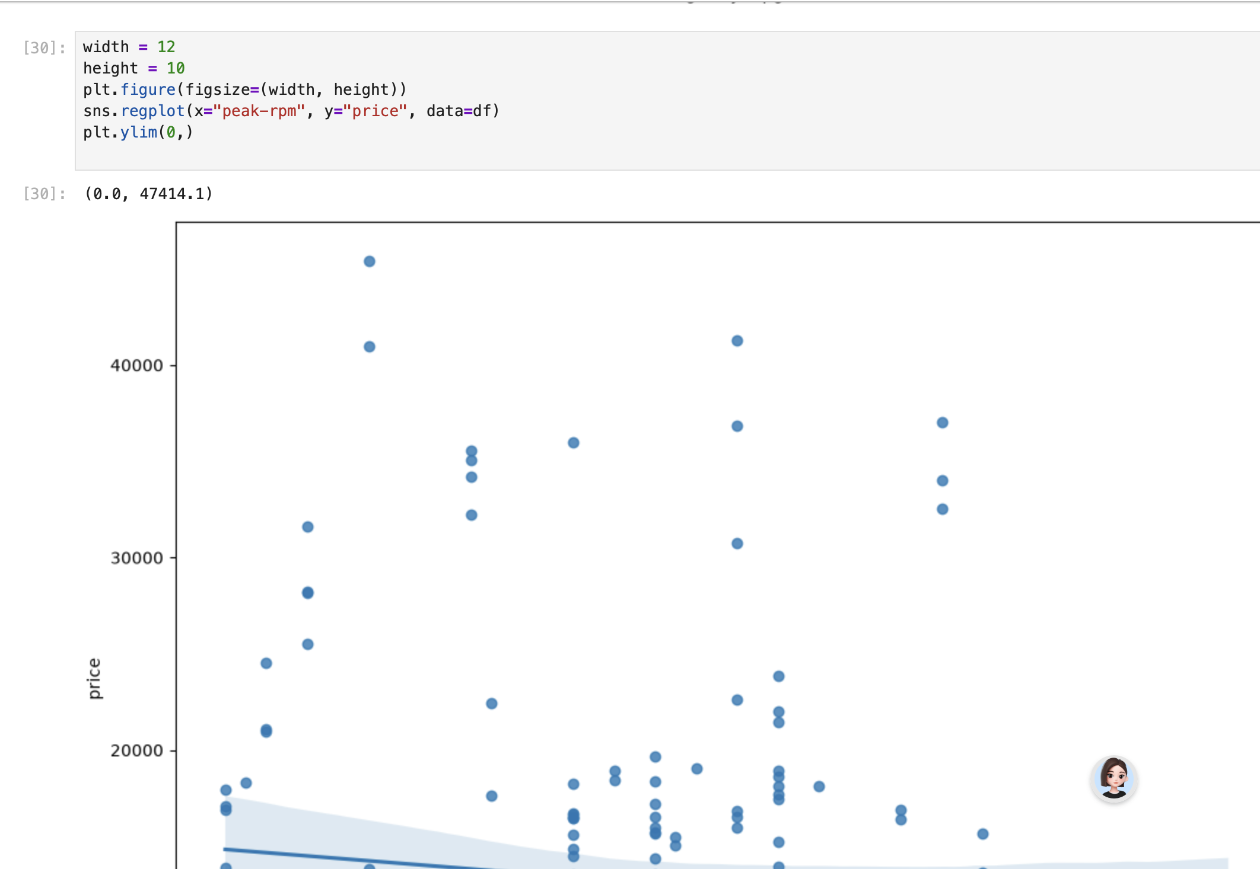
Screenshot file: 13_q2a_4mlr_lm2.png
The same relationship is redrawn with the figure size set by width and height so the scatter of the points is easier to read.

Lab1_21. Section 3 Continuing the model evaluation examples
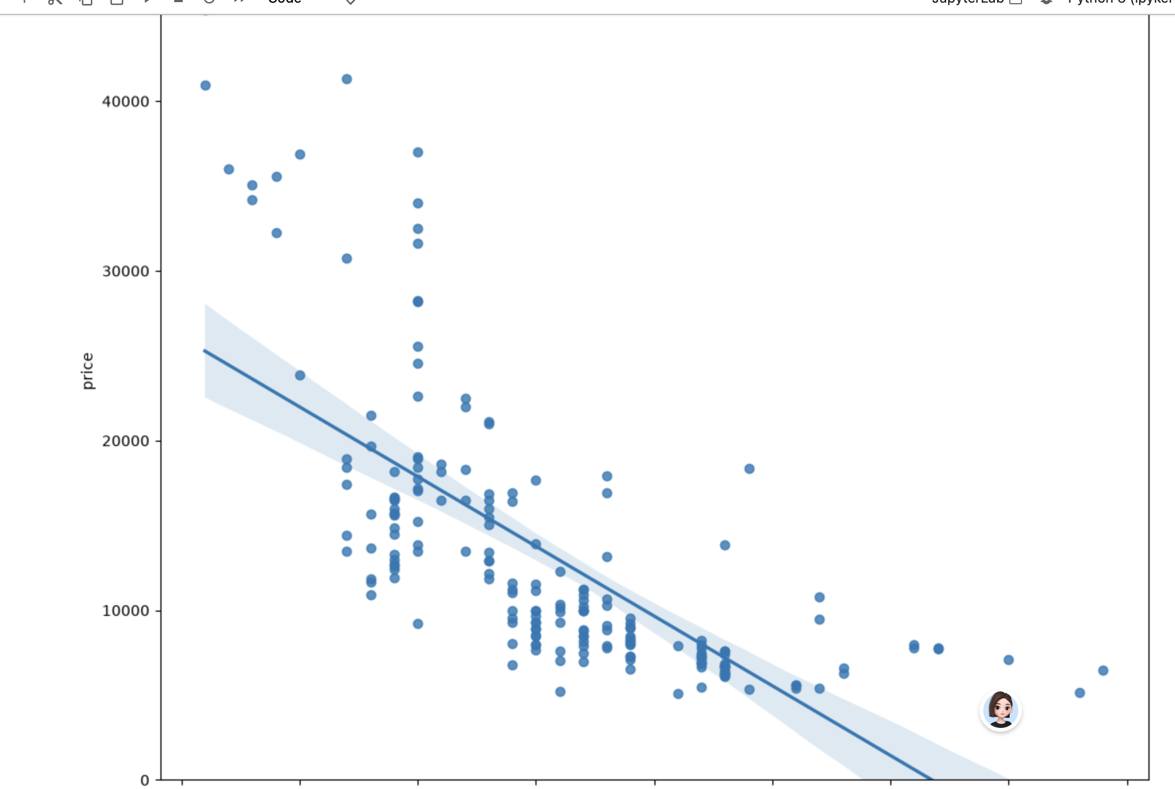
Screenshot file: 13_q2a_5mlr_lm2.png
The screenshot continues the sequence of evaluation plots that precedes the multiple regression question.

Lab1_22. Question 3 Correlation of peak-rpm and highway-mpg with price
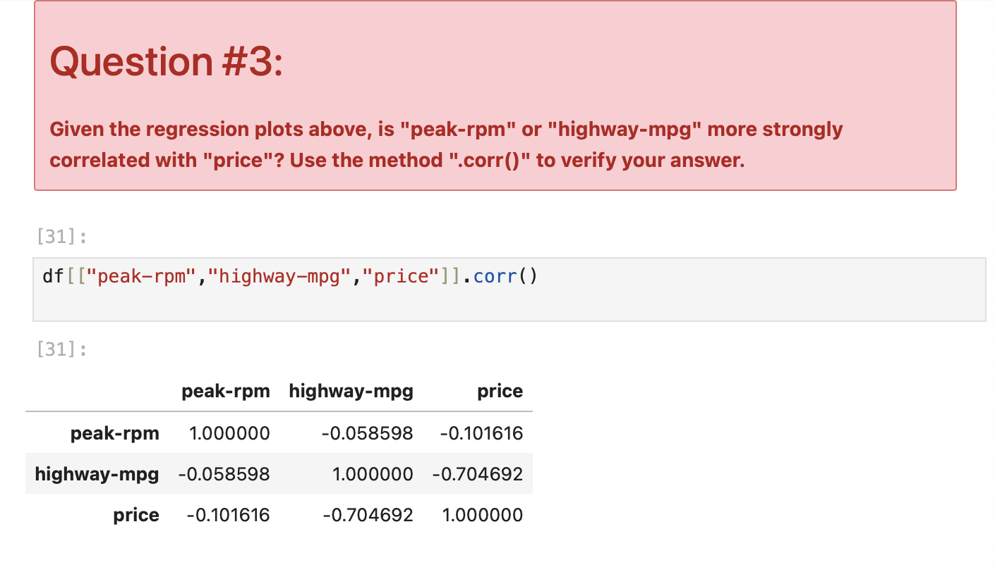
Screenshot file: 14_q3_corr_table.png
The correlation tables for the two candidate features are computed so the stronger predictor can be identified.

Lab1_23. Question 3 continued: highway-mpg against price
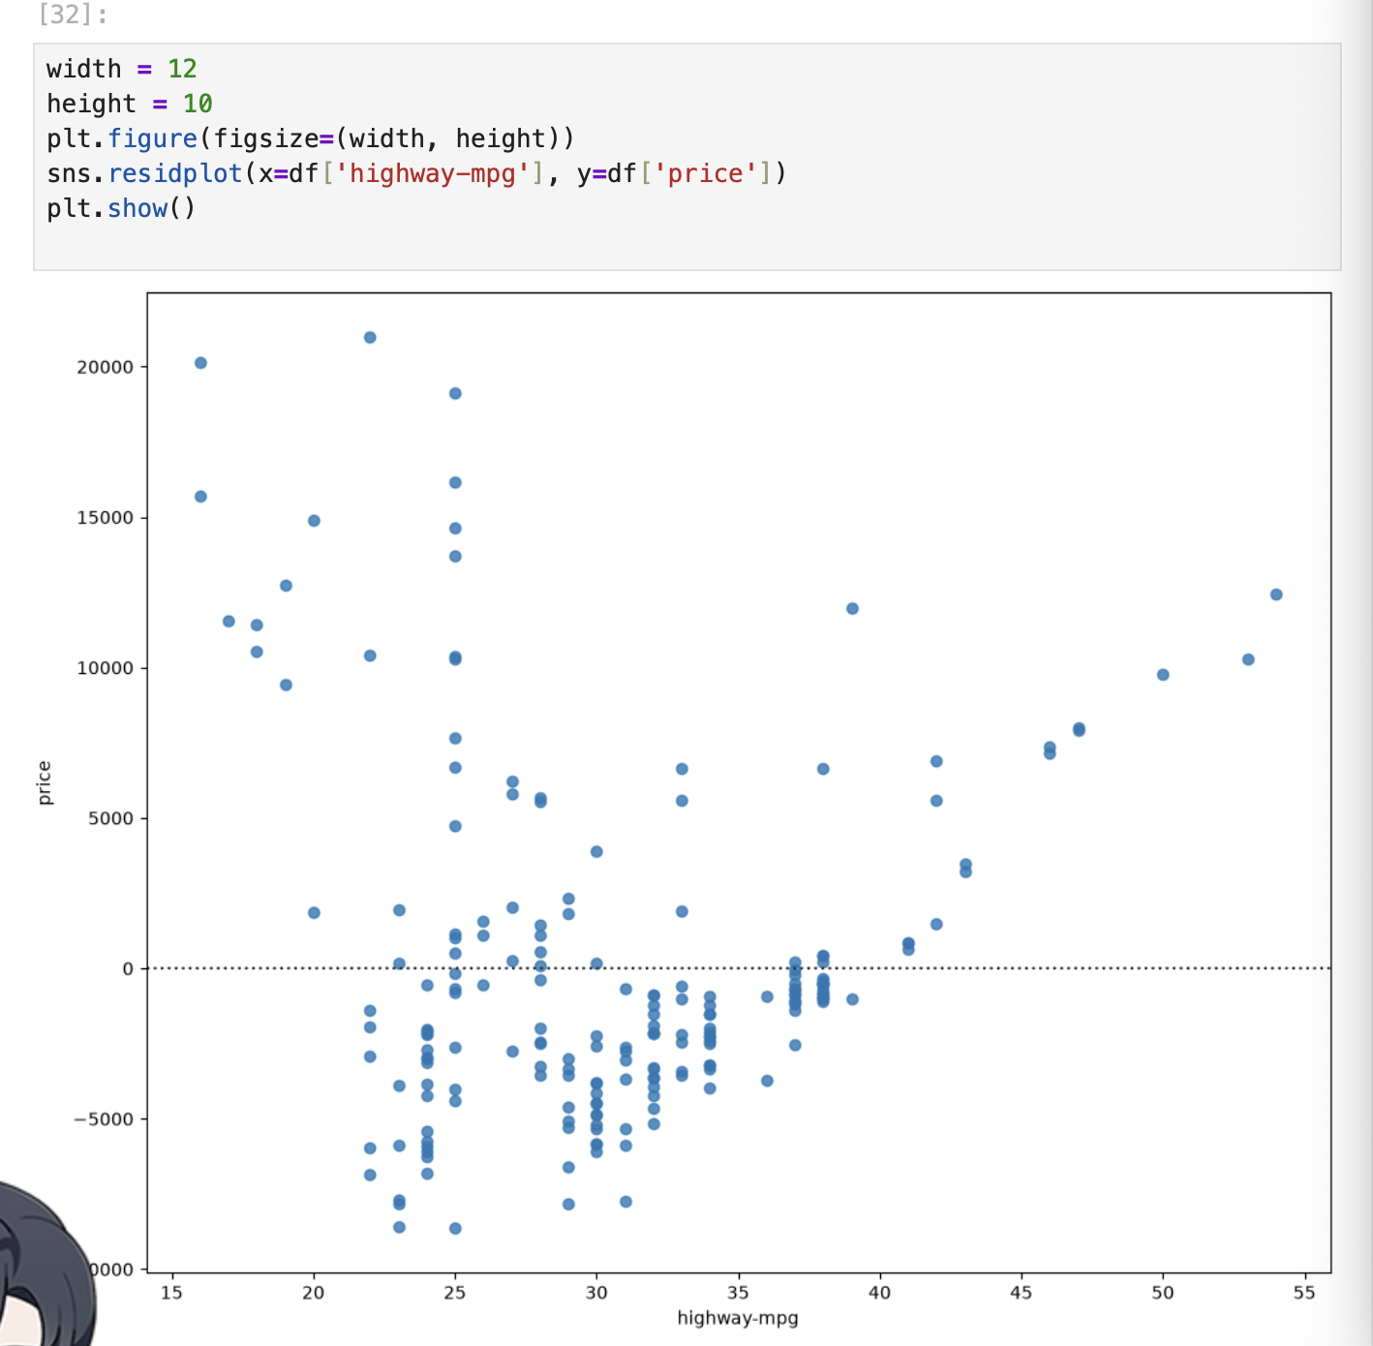
Screenshot file: 14_q3_1corr_table.png
The first table gives the correlation of highway-mpg with price, about -0.70.

Lab1_24. Question 3 continued: peak-rpm against price
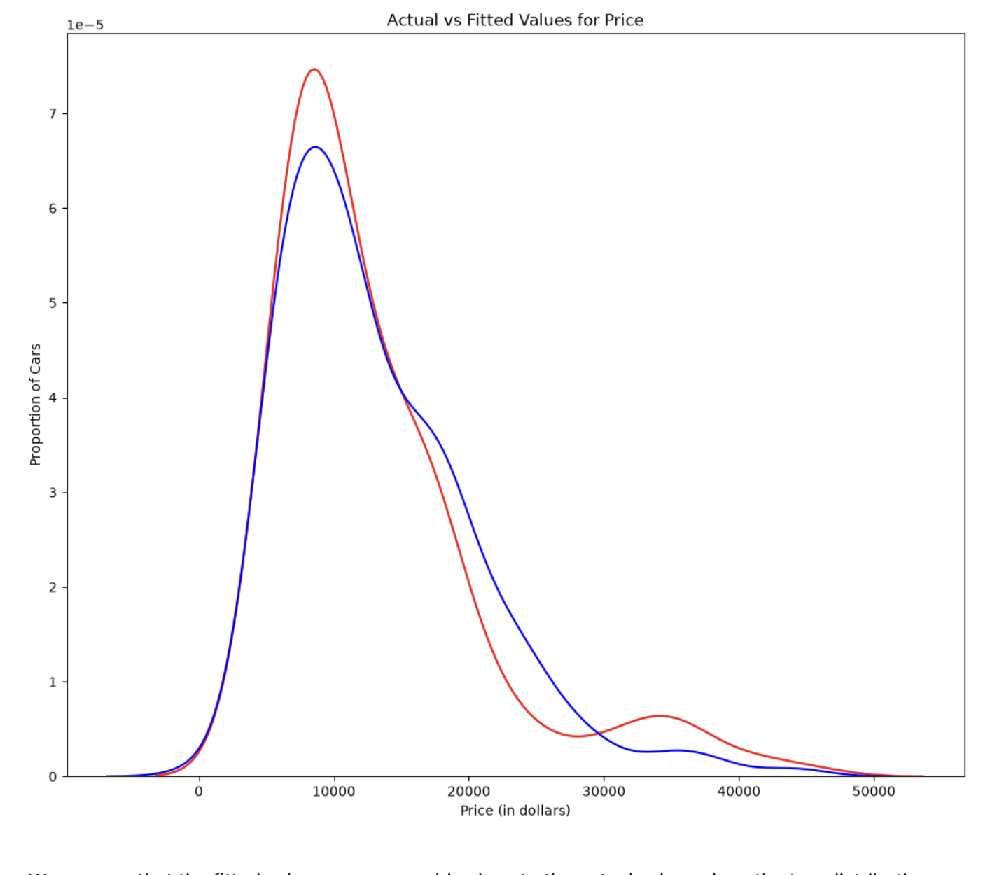
Screenshot file: 14_q3_2corr_table.png
The second table gives the correlation of peak-rpm with price, only about -0.10.

Lab1_25. Question 3 answer: highway-mpg is the stronger predictor
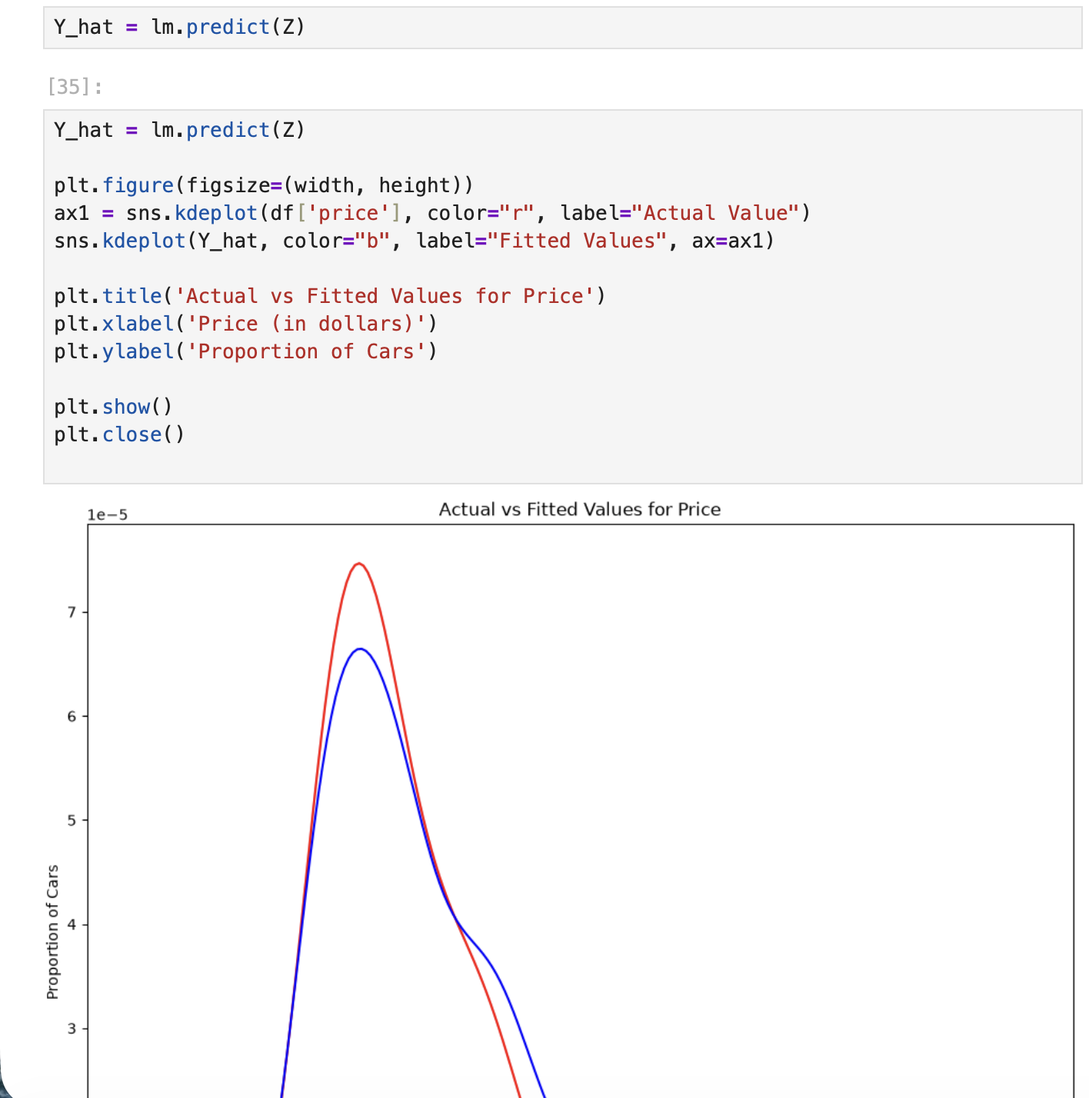
Screenshot file: 14_q3_3corr_table.png
Comparing the two tables, highway-mpg is far more strongly correlated with price than peak-rpm, which answers the question.

Lab1_26. Section 4 Defining the polynomial plot helper
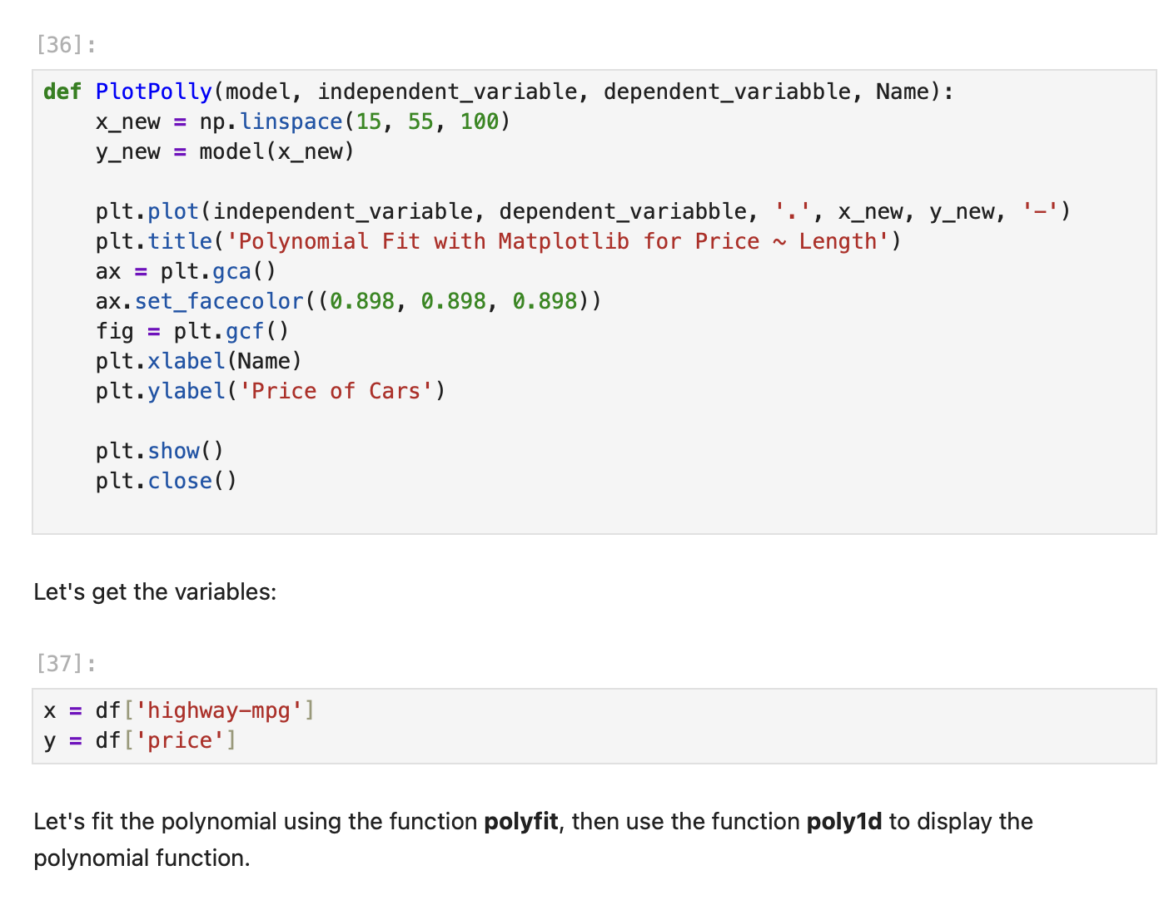
Screenshot file: 15_plotpolly_def.png
The PollyPlot function is defined so training data, test data and a polynomial fit can be drawn on the same axes.

Lab1_27. Section 4 Fitting a third order polynomial with polyfit
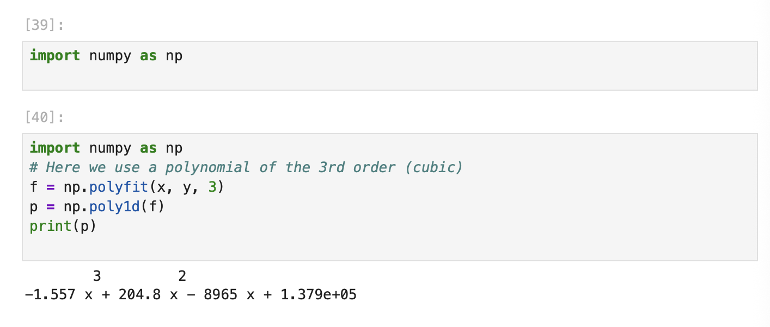
Screenshot file: 16_polyfit3_highway_mpg.png
np.polyfit with order three and np.poly1d build the cubic polynomial for highway-mpg and price.

Lab1_28. Section 4 Drawing the third order polynomial
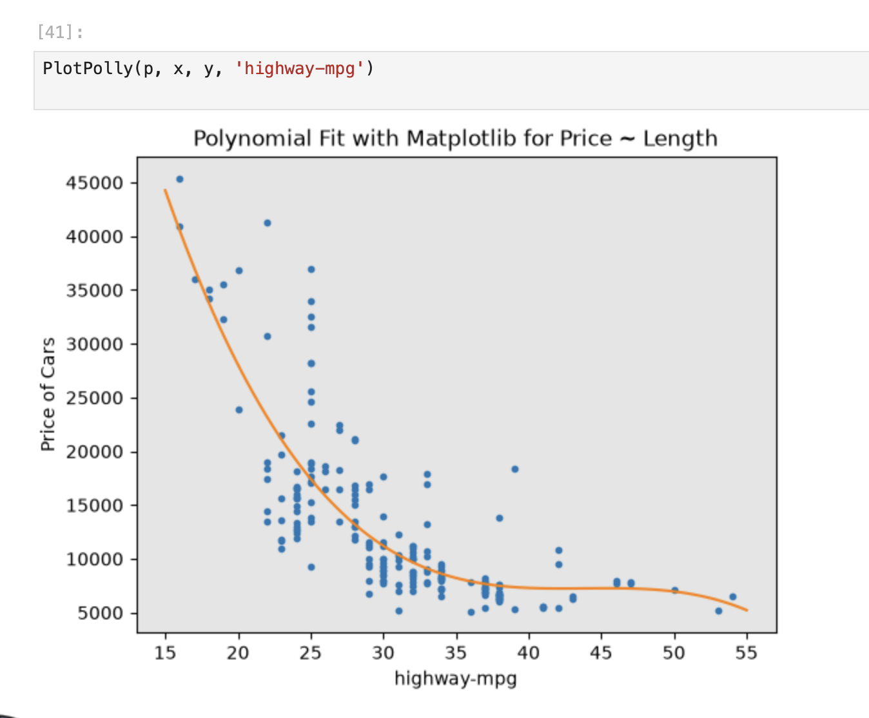
Screenshot file: 17_plotpolly_highway_3order.png
The plot compares the cubic curve with the actual points, which shows how much better the curve follows the data than a straight line.

Lab1_29. Section 4 Coefficients of the third order polynomial
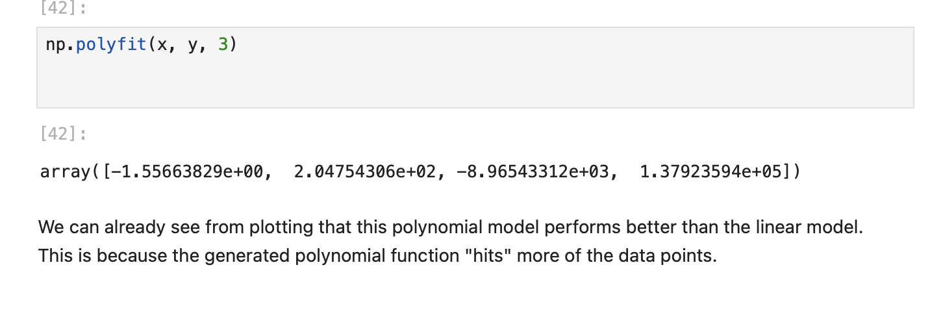
Screenshot file: 18_polyfit3_coeff.png
print(p) displays the equation of the cubic fit, the counterpart of the slope and intercept of the linear model.

Lab1_30. Question 4 Creating the eleventh order polynomial
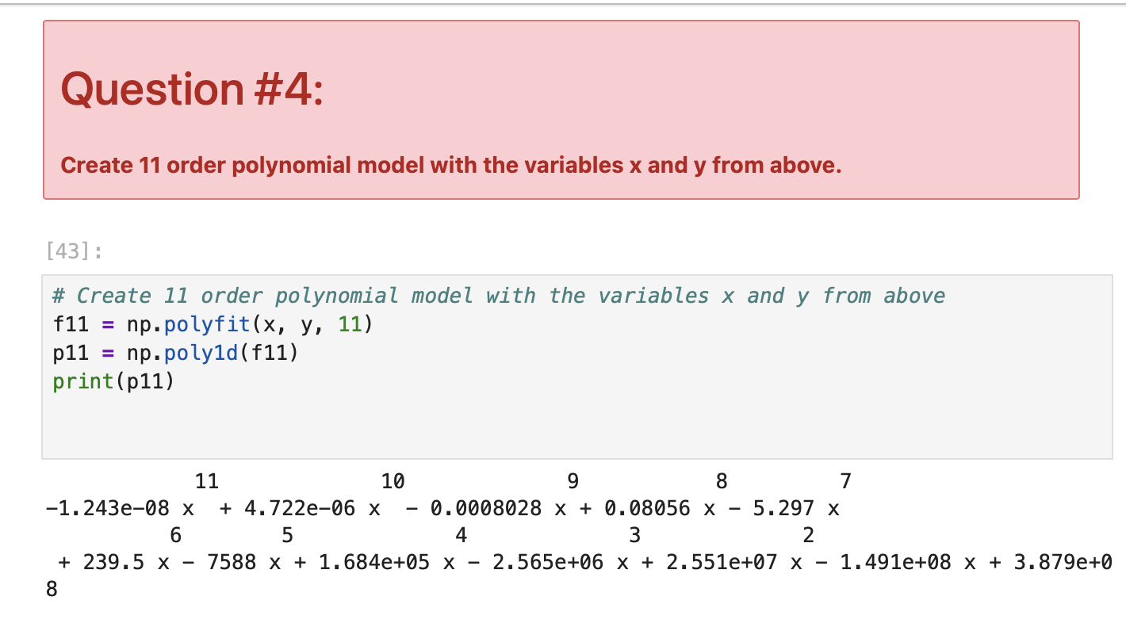
Screenshot file: 19_q4_poly11_model.png
np.polyfit with order eleven fits a very flexible curve to the same data, which is what the question asks for.

Lab1_31. Question 4 continued: the eleventh order fit
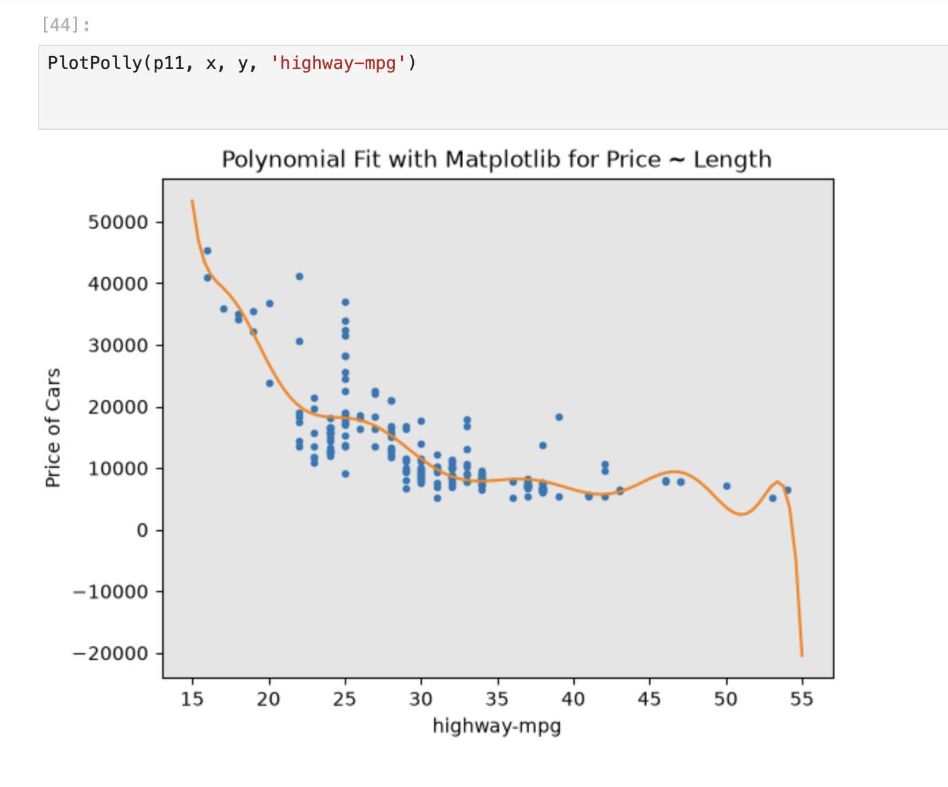
Screenshot file: 19_q4_1poly11_model.png
The high order polynomial follows the training points closely, which illustrates the overfitting that the next module examines in detail.

Lab1_32. Section 4 Polynomial features for several attributes at once
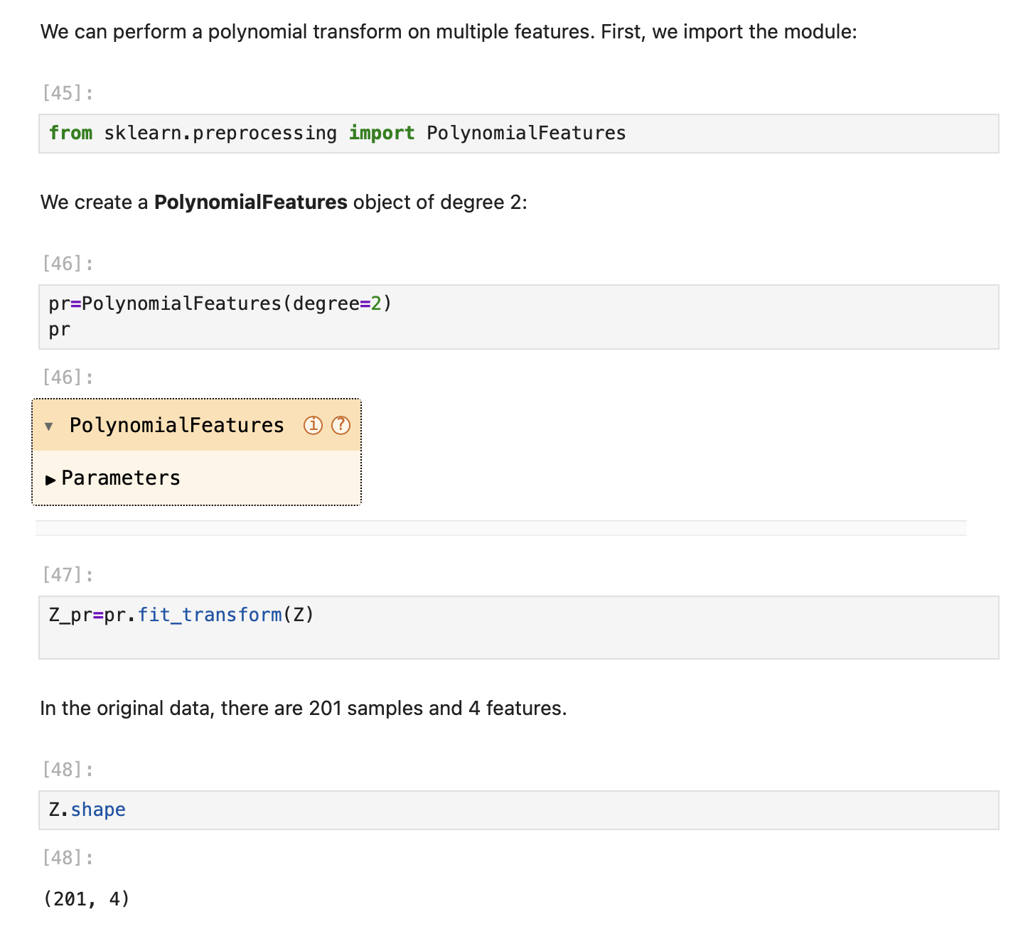
Screenshot file: 20_polyfeatures_degree2.png
PolynomialFeatures of degree two is imported and applied to the multi feature set, so the pipeline steps can be built.

Lab1_33. Section 5 Pipeline with scaling and linear regression
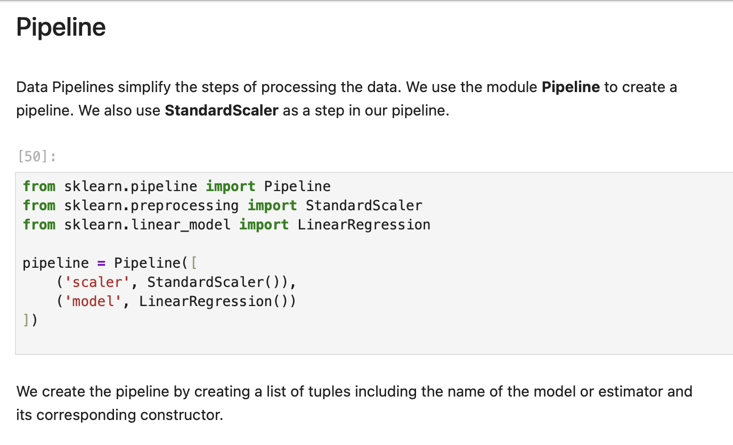
Screenshot file: 21_pipeline_linear_scaler.png
A pipeline is created from the list of tuples that pairs the name of each estimator with its constructor.

Lab1_34. Section 5 Pipeline with scaling, polynomial features and regression
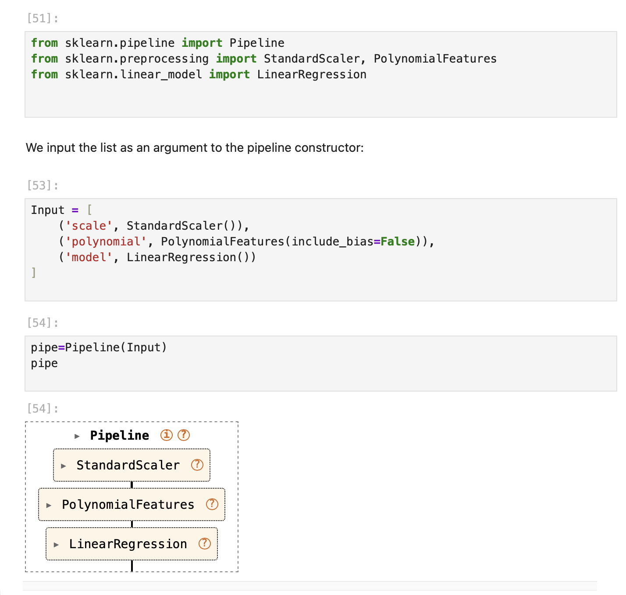
Screenshot file: 22_pipeline_poly_linear.png
The second pipeline adds PolynomialFeatures between the scaler and the regression model.

Lab1_35. Section 5 Fitting the polynomial pipeline
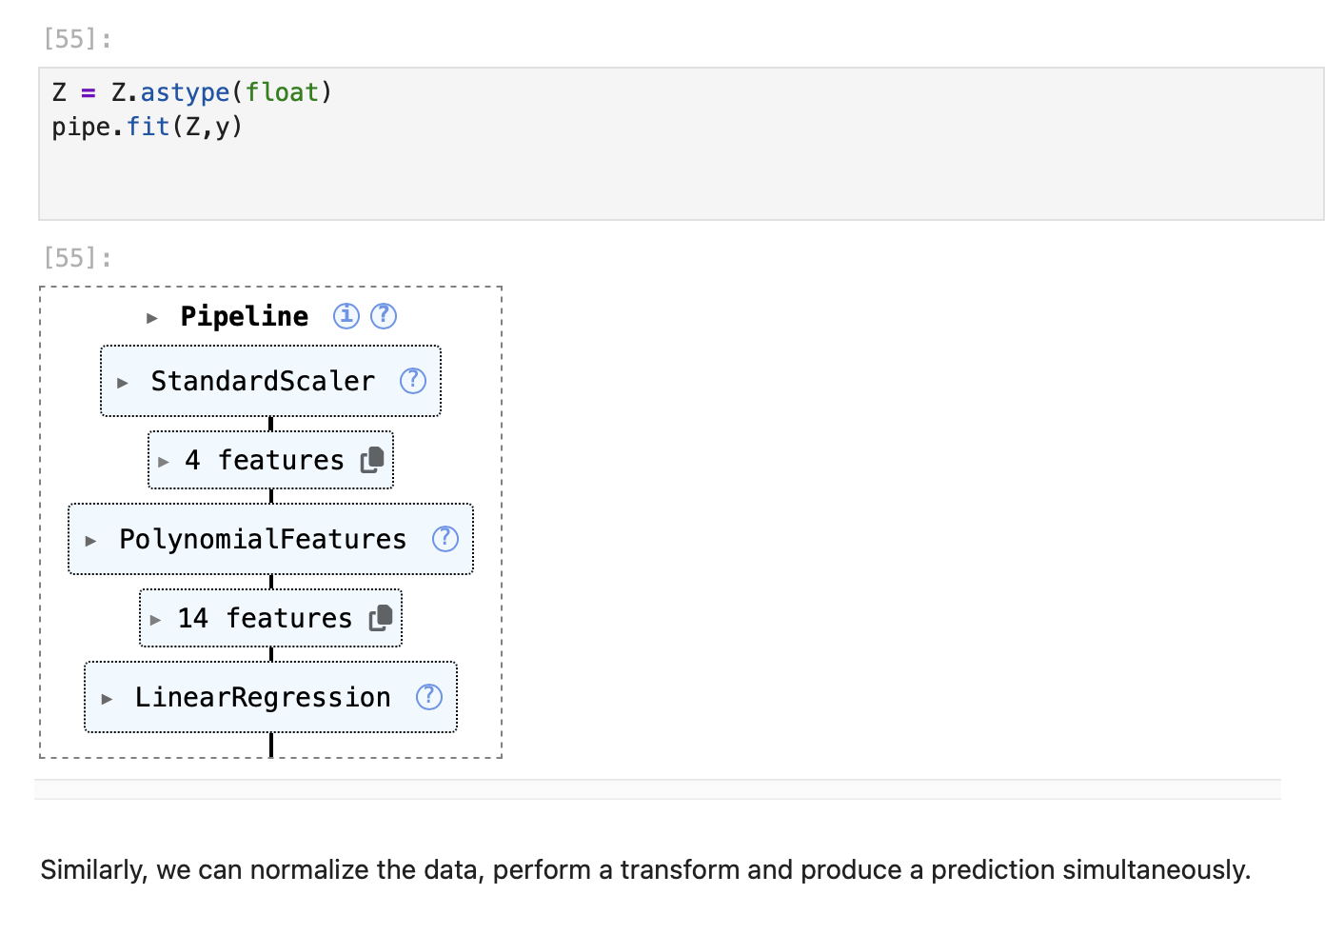
Screenshot file: 23_pipeline_fit_poly.png
pipe.fit trains all three steps of the pipeline on the four features in a single call.

Lab1_36. Section 5 Predicting with the pipeline
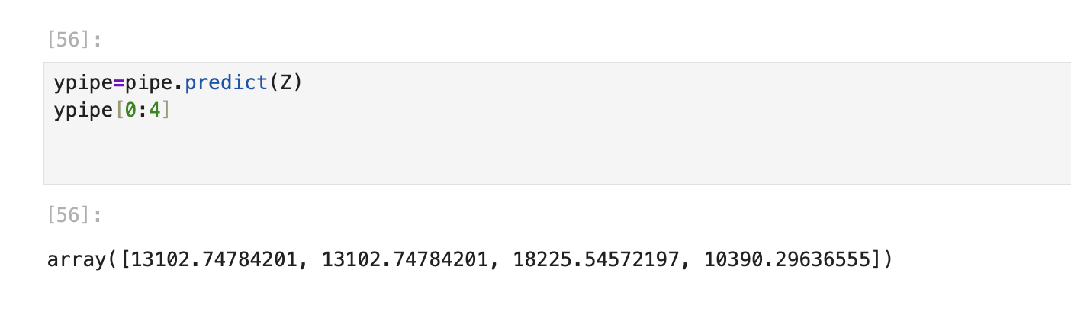
Screenshot file: 24_pipeline_predict_ypipe.png
ypipe = pipe.predict(Z) produces the fitted values and prints the first four of them.

Lab1_37. Question 5 Pipeline that standardises and then predicts
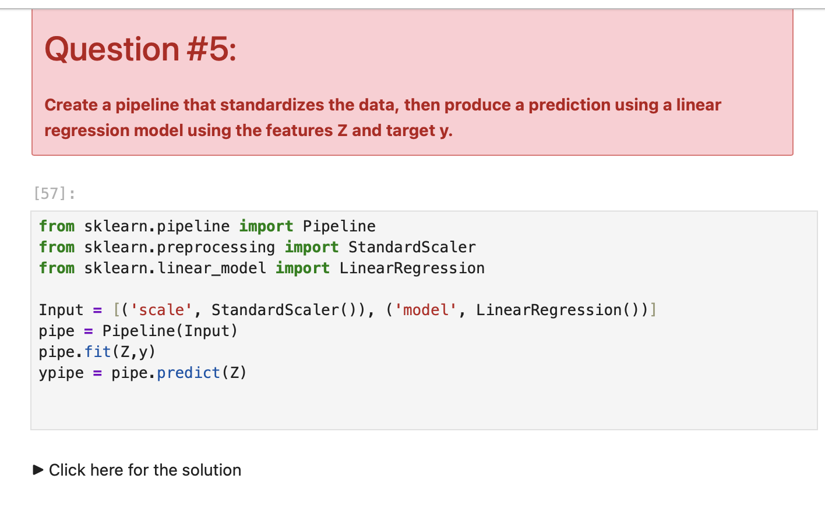
Screenshot file: 25_q5_pipeline_standard_linear.png
The answer builds the pipeline requested by the question, with the scaler followed by the linear regression model.

Lab1_38. Section 6 Mean squared error of the simple linear regression
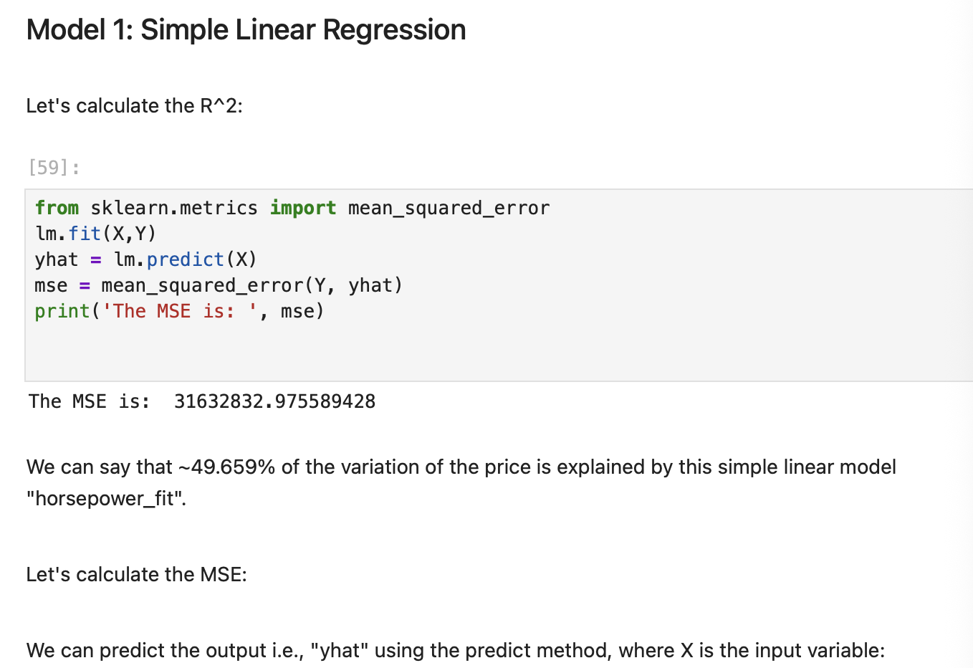
Screenshot file: 26_model1_simple_lr_mse.png
mean_squared_error compares the actual prices with the fitted values of the single variable model.

Lab1_39. Section 6 Predicted values and their error
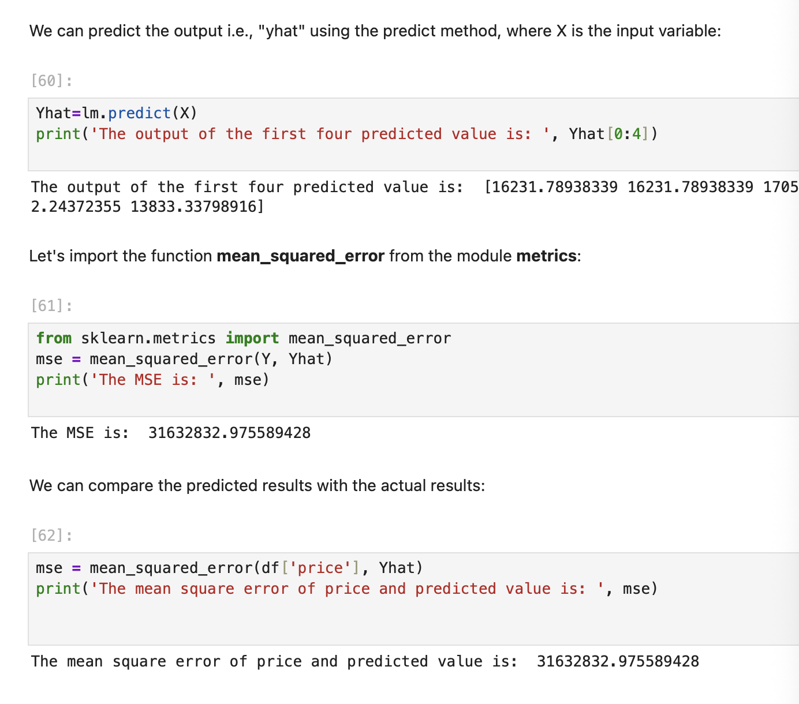
Screenshot file: 27_simple_lr_predict_mse.png
Yhat = lm.predict(X) prints the first four predictions, which are the inputs of the error calculation.

Lab1_40. Section 6 Error of the multiple regression
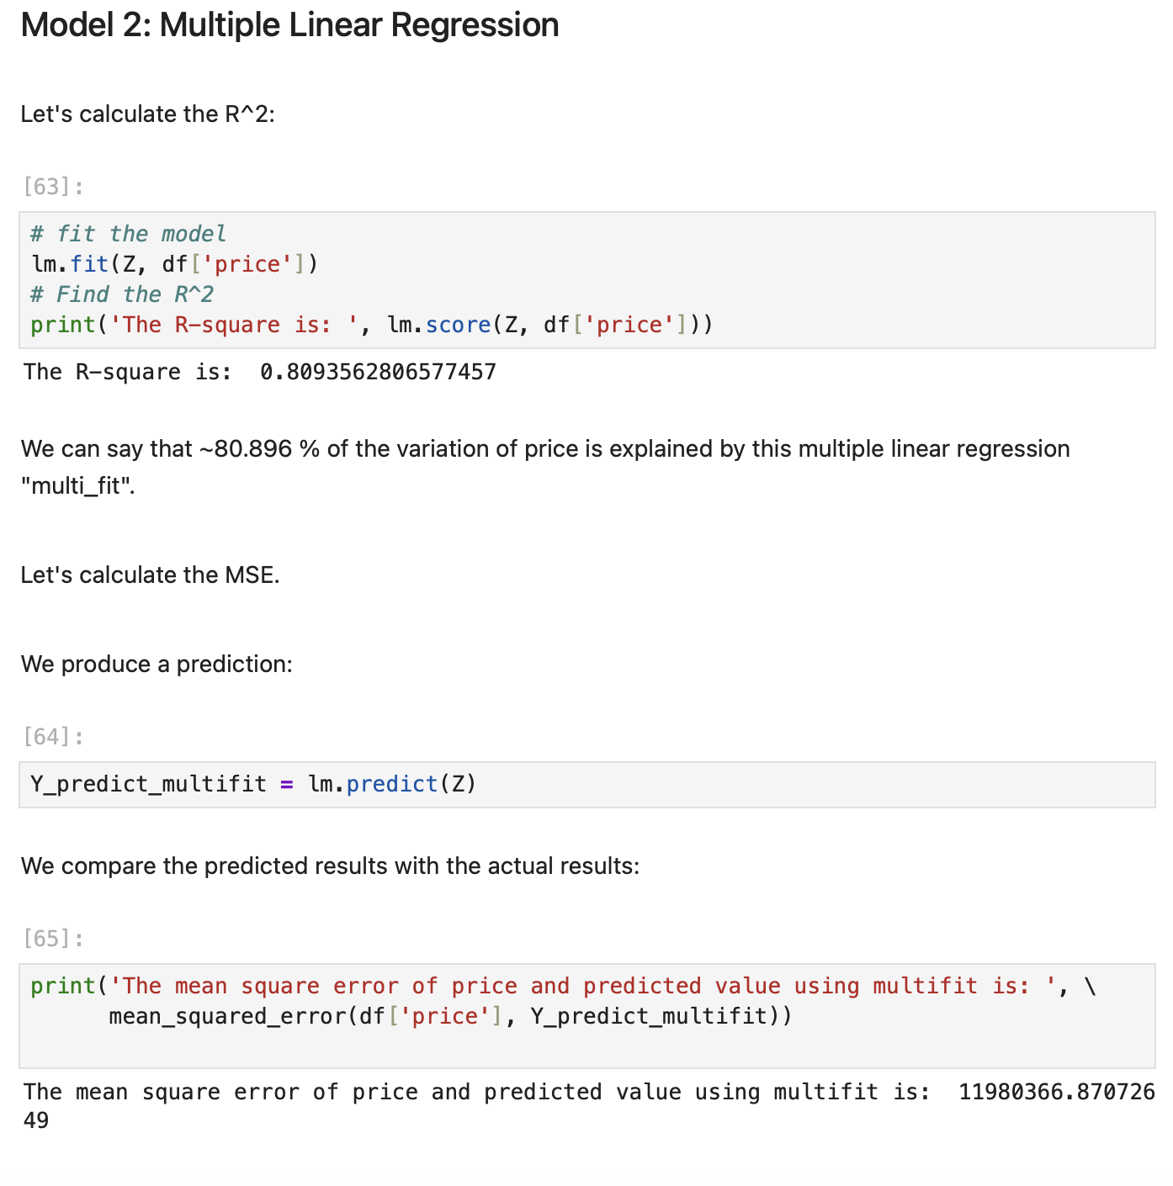
Screenshot file: 28_model2_multiple_lr_r2_mse.png
The mean squared error of the four feature model is printed so it can be compared with the simpler model.

Lab1_41. Section 6 R squared of the polynomial fit
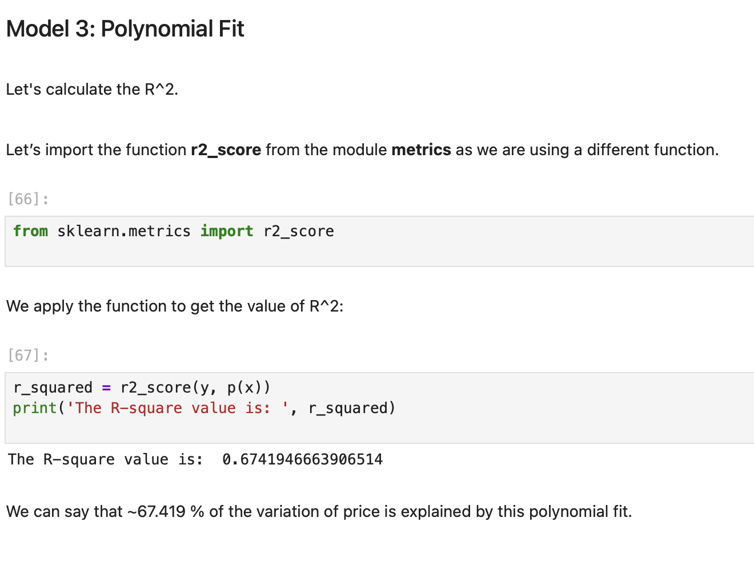
Screenshot file: 29_model3_polynomial_r2.png
r2_score on the cubic polynomial shows how much of the variation in price the curve explains.

Lab1_42. Section 6 Mean squared error of the polynomial fit
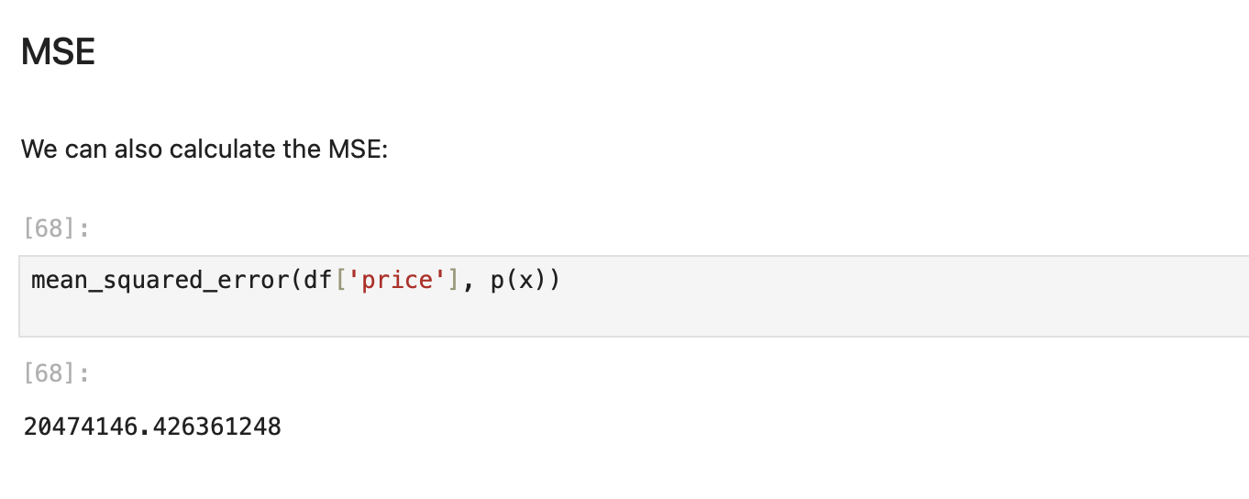
Screenshot file: 30_model3_polynomial_mse.png
The same cubic model is scored with mean_squared_error, completing the model comparison table.

Lab1_43. Section 7 Prediction and decision making
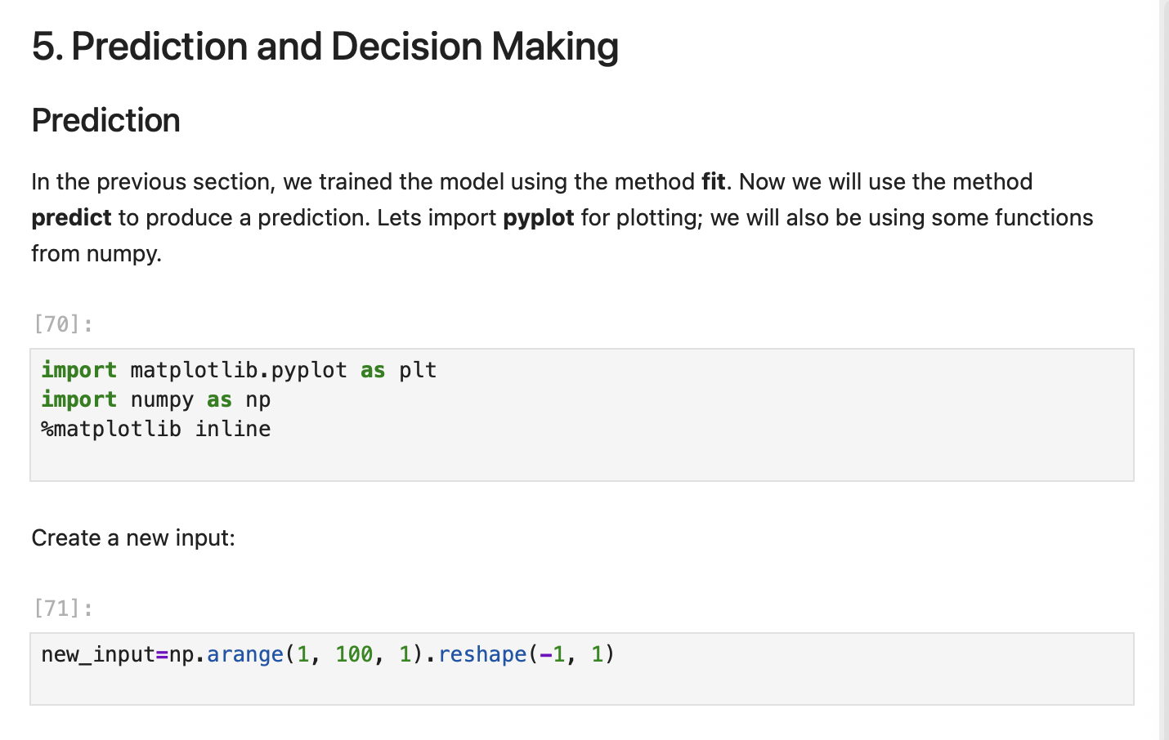
Screenshot file: 31_prediction_plot_import.png
The heading introduces the last section of the lab, where the fitted model is used to predict the price of a new car.

Lab1_44. Section 7 Fitting the simple linear model again
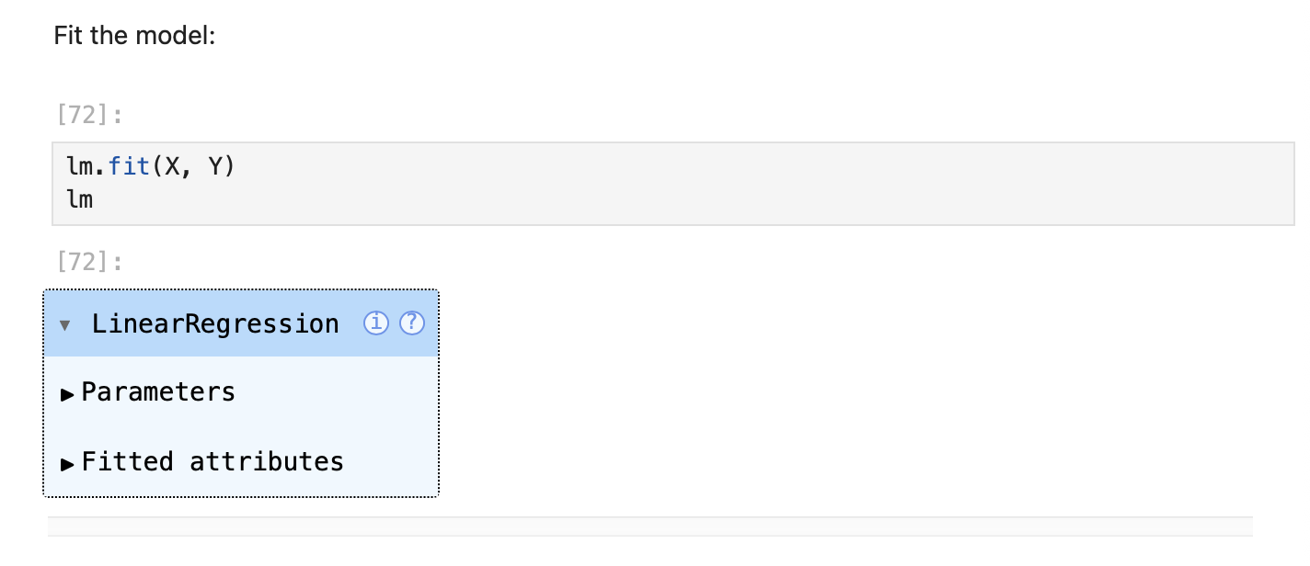
Screenshot file: 32_fit_simple_lm.png
The model is fitted once more so the prediction step below works on a known object.

Lab1_45. Section 7 Predicting a price from the engine size
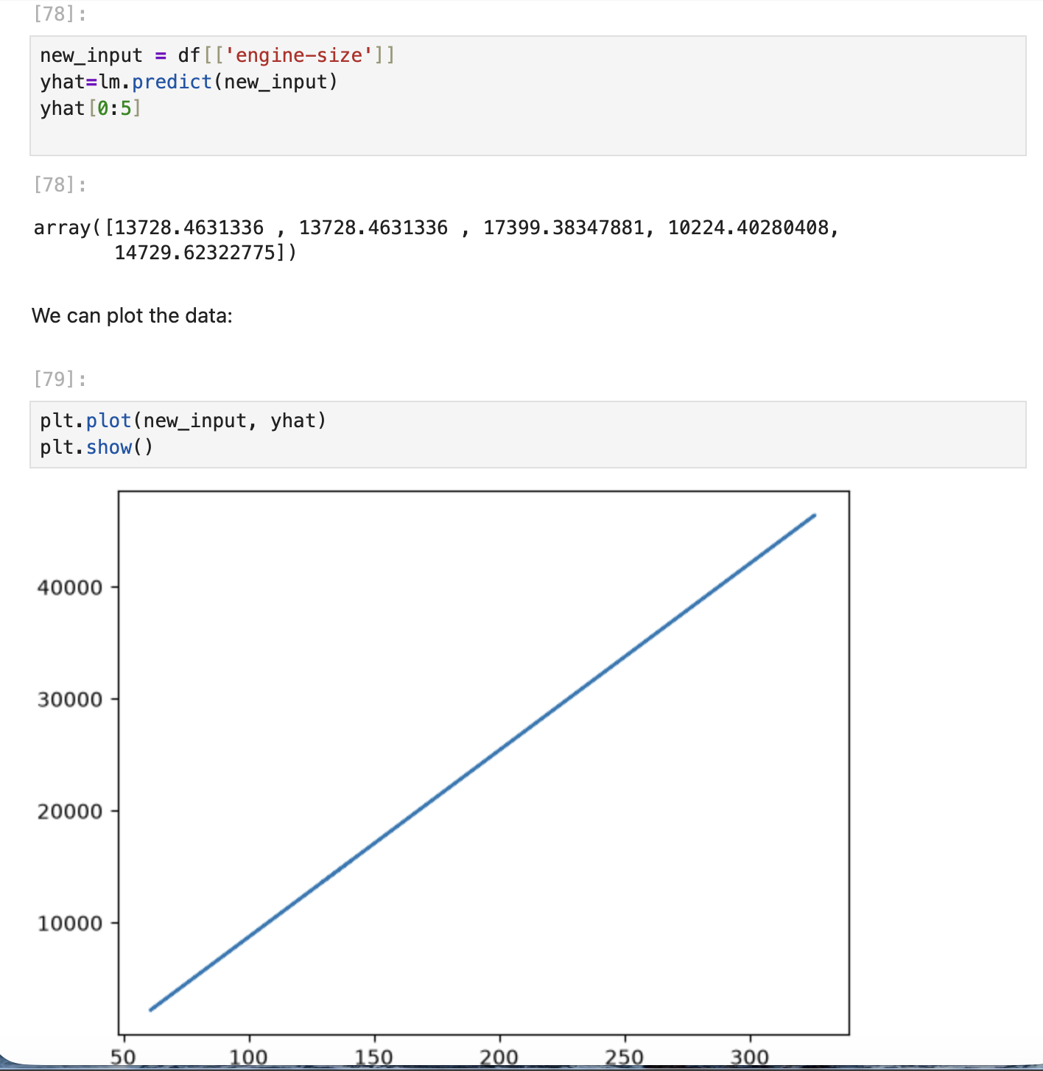
Screenshot file: 33_plot_engine_size_lr.png
new_input = df[['engine-size']] and lm.predict produce predicted prices for the first rows, which is the practical use of the model.

